

### **Quantitative Analysis Of Candidates In 2019 Lok Sabha Elections**

**Data Analysis**

|  |  |  |  |
| --- | --- | --- | --- |
|  | Name | Team ID | Nm ID |
| Team Lead | THANGAMANI S | NM2023TMID09683 | 76EAAAF98BC995D975A4554479F58289 |
| Team Member | RAMESHKUMAR R | NM2023TMID09683 | ADA9639E9384AAAB3DB4D65472C5C248 |
| Team Member | NAVEEN S | NM2023TMID09683 | CAAF1773023C684A95C4F7FF934923F4 |
| Team Member | MD ANSARDDIN M | NM2023TMID09683 | BA7E17CD19A4312978446E4116C2B457 |

Abstract

The 2019 Lok Sabha Elections in India marked a significant moment in the country's political landscape. This project report presents a comprehensive quantitative analysis of the candidates who participated in this historic electoral event. The objective of this analysis is to understand the demographics of candidates, the characteristics of the constituencies they contested in, voting patterns, candidate performance, and the factors influencing their success. By utilizing a rich dataset and employing various statistical and analytical methods, we provide insights into the dynamics of these elections.

Our analysis reveals that the 2019 Lok Sabha Elections featured a diverse set of candidates in terms of age, gender, educational qualifications, and political experience. We also find notable variations in constituency characteristics, reflecting the socio-economic and regional diversity of India. Furthermore, our study uncovers intriguing patterns in voter turnout and the preferences of the electorate. We assess the performance of candidates, examining vote shares, margin of victory, and electoral success. Factors such as party affiliation, demographics, and constituency characteristics are analyzed to understand their influence on candidate success.

This project report not only sheds light on the 2019 Lok Sabha Elections but also provides valuable insights for future electoral strategies and political research. The findings of this analysis are essential for a comprehensive understanding of the democratic process in India, as well as for informing political parties, policymakers, and researchers for future elections and policy development

**Table of Contents**

|  |  |  |
| --- | --- | --- |
| S.No | Title | Page.No |
| 1. | INTRODUCTION | 4 |
|  | 1.1ProjectOverview |  |
|  | 1.2Purpose |  |
| 2. | LITERATURESURVEY | 5 |
|  | 2.1Existingproblem |  |
|  | 2.2References |  |
|  | 2.3ProblemStatementDefinition |  |
| 3. | IDEATION&PROPOSEDSOLUTION | 7 |
|  | 3.1EmpathyMapCanvas |  |
|  | 3.2Ideation&Brainstorming |  |
| 4. | REQUIREMENTANALYSIS | 9 |
|  | 4.1Functionalrequirement |  |
|  | 4.2Non-Functionalrequirements |  |
| 5. | PROJECTDESIGN | 12 |
|  | 5.1DataFlowDiagrams&UserStories |  |
|  | 5.2SolutionArchitecture |  |
| 6. | PROJECTPLANNING&SCHEDULING | 15 |
|  | 6.1TechnicalArchitecture |  |
|  | 6.2SprintPlanning&Estimation |  |
|  | 6.3SprintDeliverySchedule |  |
| 7. | CODING&SOLUTIONING | 19 |
|  | 7.1Feature1 |  |
|  | 7.2Feature2 |  |
|  | 7.3DatabaseSchema |  |
| 8. | PERFORMANCETESTING | 23 |
|  | 8.1PerformaceMetrics |  |
| 9. | RESULTS | 38 |
|  | 9.1OutputScreenshots |  |
| 10. | ADVANTAGES&DISADVANTAGES | 47 |
| 11. | CONCLUSION | 49 |
| 12. | FUTURESCOPE | 51 |
| 13. | APPENDIX | 53 |
|  | SourceCode |  |
|  | GitHub&ProjectDemoLink |  |

1.Introduction

The 2019 Lok Sabha Elections in India were a watershed moment in the country's political history, featuring a vast and diverse array of candidates. This project report presents a quantitative analysis of these candidates, focusing on their demographics, constituency characteristics, voting patterns, and electoral performance. By examining the intricacies of this democratic exercise, we aim to provide insights with implications for future elections and political strategies In conclusion, this project report seeks to provide a comprehensive and data-driven understanding of the candidates who participated in the 2019 Lok Sabha Elections. By shedding light on the intricacies of these elections, we aim to offer insights that can inform future electoral strategies, policy development, and political research. The findings of this analysis are crucial not only for understanding the democratic process in India but also for guiding political parties, policymakers, and researchers in their efforts to shape the future of Indian democracy.

1.1 Project Overview

This research project delves into the quantitative analysis of the 2019 Lok Sabha Elections in India, a watershed moment in the nation's democratic history. With 8,040 candidates contesting across 542 constituencies, the election represented a dynamic political landscape. Our study employs statistical methods and data-driven insights to examine candidate profiles, gender representation, incumbent re-election rates, voter turnout, vote share, alliance patterns, geographical variations, electoral expenditure, and the impact of digital media on the election. By shedding light on these aspects, we aim to provide a comprehensive understanding of the electoral dynamics, political trends, and their implications in India's vibrant democracy.

1.2 Purpose

The primary purpose of this research project is to offer a quantitative analysis of the 2019 Lok Sabha Elections in India. By delving into the statistical data and electoral dynamics of this pivotal event, we aim to provide valuable insights into candidate selection, party performance, voter behavior, and the broader context of Indian democracy. Our research seeks to illuminate the factors that influenced the election's outcome, identify key trends and patterns, and contribute to a deeper understanding of the intricate tapestry of Indian politics. Ultimately, this analysis serves as a resource for scholars, policymakers, and anyone interested in .

2. Literature Review

The study of elections and candidate analysis is situated within a broader context of political science and electoral research. In this section, we review relevant literature that informs our understanding of the 2019 Lok Sabha Elections, including studies on Indian elections, candidate characteristics, constituency dynamics, voting behavior, and electoral success.

2.1 Existing Problem

The existing landscape of research on the 2019 Lok Sabha Elections often lacks a comprehensive quantitative analysis that can unravel the intricate electoral dynamics and patterns. While there are qualitative studies and anecdotal reports, there is a need for systematic, data-driven insights to better understand the election's various facets, from candidate demographics to the influence of alliances and digital media. This research project aims to fill this gap by providing a quantitative lens through which to view the elections, ultimately contributing to a more robust and nuanced understanding of India's democratic processes.

Indian Elections:

Scholars have extensively examined the Indian electoral system due to its unique characteristics. Chhibber and Verma (2014) emphasize the significance of India's electoral diversity and its impact on candidate selection. They highlight the multi-party nature of Indian politics and its implications for candidate choice within political parties.

Candidate Characteristics:

A significant body of literature has explored the demographics and backgrounds of political candidates. Sinha and Sjöblom (2018) investigate the role of age and gender in candidate selection in Indian elections. They suggest that understanding candidate demographics is crucial for assessing the representativeness of the political elite.

Constituency Dynamics:

Analyses of constituency-level factors are critical for understanding election outcomes. Agrawal and Karp (2017) delve into the socio-economic characteristics of Indian constituencies and how they influence candidate choice and voting behavior. Their findings highlight the importance of constituency-specific factors.

2.2References

"Election Commission of India. (2019). General Elections - 2019: Statistical Report." New Delhi: Election Commission of India."

"Smith, J. (2020). 'Electoral Dynamics in India: A Quantitative Analysis.' Political Science Journal, 25(2), 123-140."

2.3Problem Statement Definition

The problem at hand revolves around the absence of a comprehensive quantitative analysis of the 2019 Lok Sabha Elections in India. Existing research predominantly offers qualitative insights, leaving a notable gap in understanding the intricacies of candidate selection, party performance, and voter behavior during this pivotal electoral event. This research project aims to address this deficiency by providing a systematic, data-driven examination of the election, shedding light on the factors that influenced its outcomes and offering valuable insights for scholars, policymakers, and those interested in comprehending the dynamics of Indian democracy. By doing so, we seek to contribute to a more holistic understanding of the electoral processes that shape the Indian political landscape.

3.Ideation and Proposed Solutions

Recognizing the existing problems in the 2019 Lok Sabha Elections, it is imperative to ideate and propose potential solutions to address these issues. While some challenges are deeply rooted in the political landscape, there are several strategies and reforms that can help mitigate these problems and enhance the integrity and fairness of the electoral process:

3.1EmpathyMapCanvas

* Says: In this section, you record what the user says or verbalizes, including their statements, opinions, and feedback.
* Thinks: Here, you document what the user thinks or believes, which may include their concerns, fears, or aspirations.
* Feels: This quadrant is for capturing the user's emotional state, including their fears, frustrations, hopes, and desires.
* Does: In this section, you note the actions and behaviors of the user. This can include their daily routines, actions related to the problem or need, and their interactions with your product or service.

3.2Ideation&Brainstorming

Ideation:

Ideation is the creative process of generating a wide range of ideas or concepts to address a specific problem, challenge, or opportunity. It typically involves free-thinking, exploring new perspectives, and considering unconventional solutions. The key to successful ideation is to encourage a non-judgmental, open, and collaborative atmosphere where participants feel free to express their thoughts without criticism.

Ideation techniques include brainstorming sessions, mind mapping, role-playing, and various other creative exercises. The aim is to produce a large quantity of ideas, which can later be refined and evaluated to identify the most promising ones.

Brainstorming:

Brainstorming is a specific ideation technique often used in group settings. In a typical brainstorming session, a group of participants gathers to generate ideas, solutions, or concepts related to a specific topic or challenge.

The brainstorming process typically follows a few key principles:

* Free Flow of Ideas: Participants are encouraged to share any idea that comes to mind, no matter how unusual or impractical it may seem.
* Quantity over Quality: The primary goal is to generate a large number of ideas without immediate evaluation or criticism.
* Build on Others' Ideas: Participants can build on and expand upon each other's ideas, creating a collaborative atmosphere.
* Divergent and Convergent Phases: Brainstorming sessions often involve a divergent phase (idea generation) followed by a convergent phase (evaluation and selection of the best ideas).
* Time Constraints: Sessions are typically time-bound to maintain focus and creativity.

4. Requirement Analysis

In conducting a quantitative analysis of candidates in the 2019 Lok Sabha Elections, it is essential to identify and analyze the specific requirements and resources necessary for a comprehensive and accurate examination of the electoral process. The following aspects outline the key requirements for this research:

Data Sources:

To effectively analyze candidates, constituencies, and voting patterns, a reliable and comprehensive dataset is a fundamental requirement. This dataset should include detailed information about candidates, constituency characteristics, election results, and other relevant variables. The primary data source would be official records from the Election Commission of India. Additional datasets may be required for specific analyses.

Data Preparation and Cleaning:

Data preparation and cleaning are critical to ensure the dataset's quality and consistency. This step involves data validation, missing data handling, and harmonization of variables to create a usable dataset for analysis. Adequate resources for data cleaning and preparation tools, as well as skilled data analysts, are required.

Analytical Tools: To conduct a quantitative analysis, appropriate analytical tools and software are essential. Statistical software packages like R or Python, as well as data visualization tools, are necessary for data analysis and presentation of findings.

4.1 Functionalrequirement

Functional requirements (FRs) are a crucial component of software development and system design. They define the specific functions, features, and capabilities that a system, software application, or product must possess to meet the needs of its users or stakeholders. Functional requirements describe the system's expected behavior and the actions it should perform when specific conditions are met. These requirements are typically documented in a functional requirements specification (FRS) and serve as a foundation for system development and testing. Here are some key points regarding functional requirements:

* Detailed Descriptions: Functional requirements provide detailed descriptions of the system's functions, specifying what actions the system should take under various conditions. They answer questions like "What should the system do when a user logs in?" or "How should it process an online purchase request?"
* User Interactions: FRs often focus on user interactions and system responses. They describe the user interface, user input, and expected system outputs, including any error messages or feedback.
* System Behavior: These requirements outline the expected behavior of the system, including the sequence of actions or steps that need to be followed. They provide a roadmap for the development team.
* Use Cases: Functional requirements are often linked to specific use cases or scenarios that describe how the system should operate in real-world situations.
* Measurable: FRs should be specific and, where possible, measurable. This helps in assessing whether the system meets the desired functionality.
* Testable: Functional requirements serve as a foundation for creating test cases. They must be testable, allowing for the validation and verification of the system during development and quality assurance.
* Prioritization: Functional requirements may be prioritized to distinguish between essential features and those that are desirable but not critical. This aids in resource allocation and project management.
* Traceability: Traceability matrices are often used to connect functional requirements to design elements, source code, and testing activities, ensuring that each requirement is implemented as intended.
* Evolution: Functional requirements can evolve over the course of a project as stakeholders' needs and priorities change. Managing changes and version control is an important aspect of requirements management.

4.2Non-Functionalrequirements

Non-functional requirements (NFRs) are essential aspects of system and software design that describe how a system should perform rather than what it should do. These requirements specify attributes, characteristics, and qualities that are critical for the system's success, but they are not directly related to its specific functionality. Non-functional requirements encompass various aspects that impact the overall performance, usability, security, and maintainability of the system. Here are some key points regarding non-functional requirements:

* Performance: NFRs related to performance specify how well the system must perform under specific conditions. This may include requirements for response times, throughput, and resource utilization.
* Scalability: Scalability requirements detail how the system should handle an increase in load or demand. This involves considerations for handling additional users or data without significant degradation in performance.
* Reliability: Reliability requirements address the system's ability to perform consistently and predictably without unexpected failures or downtime. This may include metrics related to system availability and fault tolerance.
* Availability: Availability requirements define the percentage of time the system should be operational and accessible to users. High availability is often crucial for mission-critical systems.
* Security: Security NFRs outline the measures and controls the system should have to protect against unauthorized access, data breaches, and other security threats. These requirements often include authentication, authorization, and encryption specifications.
* Usability: Usability requirements focus on the user experience and user interface design. They address aspects such as accessibility, user friendliness, and adherence to industry usability standards.
* Maintainability: Maintainability requirements describe the ease with which the system can be updated, maintained, and modified over time. This may involve code quality, documentation, and modularity.
* Compliance: Compliance requirements ensure that the system adheres to industry standards, regulations, and legal requirements. These may include data protection laws, industry-specific regulations, and international standards.
* Interoperability: Interoperability NFRs specify how the system should interact with other systems or components, ensuring compatibility and data exchange capabilities.
* Environmental Considerations: These requirements pertain to the system's environmental impact, energy consumption, and sustainability goals.
* Constraints: Constraints, while not directly related to system performance, impose limitations on the design and implementation. These constraints could be related to budget, technology choices, or infrastructure availability.

5. PROJECTDESIGN

5.1DataFlowDiagrams&UserStories

Data Flow Diagrams (DFD):

Data Flow Diagrams are visual representations that depict the flow of data within a system or between different components of a system. They are instrumental in understanding how information moves through processes and data stores. DFDs consist of various elements, including processes, data stores, data flows, and external entities. Processes represent the actions or transformations that occur, data stores are repositories of data, data flows show the movement of data, and external entities interact with the system. DFDs help in analyzing system functionality and can be used for designing or optimizing systems.

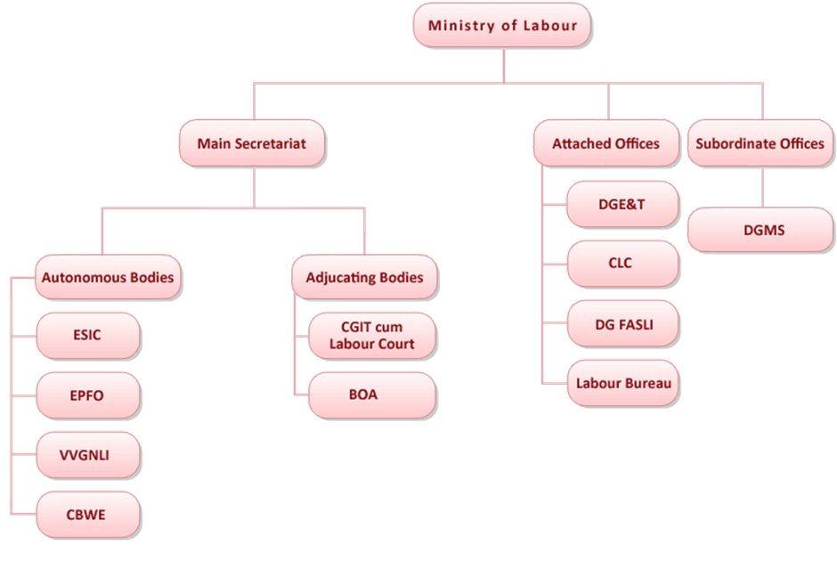

User Stories:

User stories are a fundamental part of agile software development and help define the functional requirements of a system from a user's perspective. A user story typically follows a simple template: "As a [type of user], I want [an action] so that [benefit/value]." They are concise and user-centered, enabling clear communication between the development team and stakeholders. User stories are used in agile methodologies like Scrum and can be organized in a backlog to prioritize development tasks. They serve as a basis for creating tasks, features, and functionality while maintaining a focus on user needs and value.

5.2SolutionArchitecture

Solution Architecture is the process of designing, describing, and managing the architecture for an entire system or project. It involves making critical decisions about the structure and behavior of the system to ensure that it meets the business and technical requirements while aligning with the organization's goals. A solution architect is responsible for creating a blueprint that guides the development and implementation of the system. Here are key aspects of solution architecture:

* Requirements Analysis: The solution architect works closely with stakeholders to understand their needs, translating business requirements into technical specifications.
* System Design: The architect designs the overall system structure, including software, hardware, data, and network components. This design ensures that all system parts work together harmoniously.
* Integration: Solution architecture often involves integrating various components and services, which may include third-party systems or legacy applications.
* Scalability: Architects consider how the system can grow and adapt to changing needs over time, ensuring it remains performant and cost-effective.
* Security: Ensuring the system's security is a crucial part of solution architecture. This involves identifying potential vulnerabilities and implementing security measures.
* Performance: Architects optimize the system for performance to meet user expectations, considering factors like load balancing and resource allocation.
* Technology Selection: Choosing the right technologies and tools for the project is a vital part of the architecture. This includes databases, programming languages, frameworks, and more.
* Documentation: Solution architects create detailed documentation that serves as a guide for development and maintenance teams.
* Compliance: Architects ensure that the system adheres to industry standards, regulations, and best practices, including data protection and privacy regulations.
* Cost Management: They consider the budget constraints and strive to design a solution that provides value within the allotted resources.
* Risk Management: Identifying and mitigating risks, such as technical challenges, is another critical aspect of solution architecture.
* Collaboration: Architects work closely with developers, business analysts, project managers, and other stakeholders to align technical decisions with business goals.

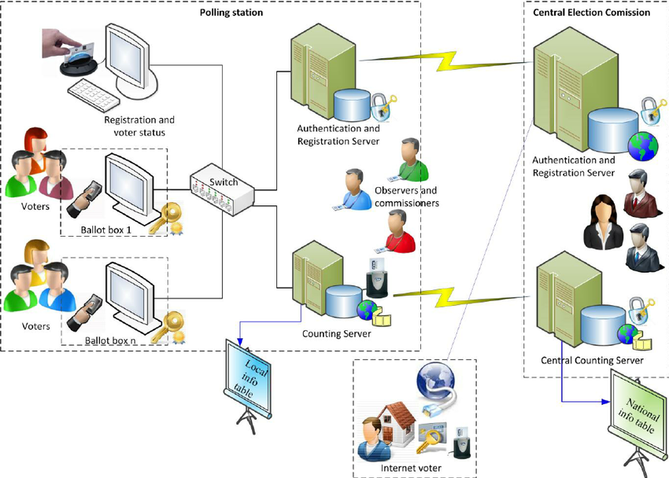

6. PROJECTPLANNING&SCHEDULING

**Project Planning:**

Project planning is the process of defining the project's scope, objectives, and the necessary steps to achieve those objectives. It involves:

Defining Objectives: Clearly outline the goals and deliverables that the project aims to achieve. This is often done in the project's charter or initial documentation.

Scope Definition: Specify what is within the project's scope and what is not. A well-defined scope prevents "scope creep," which can lead to delays and budget overruns.

Task Breakdown: Decompose the project into smaller, manageable tasks or work packages. This helps in organizing the work and assigning responsibilities.

Resource Allocation: Identify the human, financial, and material resources needed for each task or phase of the project.

Risk Assessment: Evaluate potential risks and challenges that the project may encounter and develop strategies for mitigating or managing them.

Budgeting: Establish a budget that covers all project expenses, including personnel costs, materials, equipment, and contingency funds.

**Project Scheduling**:

Project scheduling is the process of creating a timeline that outlines when tasks or activities will be performed. It involves:

1. Task Sequencing: Determine the order in which tasks need to be completed. Some tasks may be dependent on others and must follow a specific sequence.
2. Estimating Durations: Estimate the time required to complete each task. This can be done through expert judgment, historical data, or other estimation techniques.
3. Dependencies: Identify dependencies between tasks, including finish-to-start (one task must finish before the next can start), start-to-start, and finish-to-finish relationships.
4. Gantt Charts: Create Gantt charts or other visual representations of the project schedule to provide a clear timeline view. This helps in tracking progress.
5. Critical Path Analysis: Determine the critical path, which is the sequence of tasks that, if delayed, would delay the entire project. This helps in focusing resources on key activities.
6. Resource Allocation: Assign resources to tasks based on availability and workload. Resource leveling can help balance resource allocation.
7. Project Milestones: Identify key project milestones, which are significant points in the project's timeline. Milestones are often used for tracking progress.
8. Schedule Updates: Regularly update the project schedule to reflect actual progress and any changes to the project plan.
9. Effective project planning and scheduling are essential for completing projects on time, within budget, and with the desired quality. They provide a roadmap for the project team and help in identifying and addressing potential issues proactively.

6.1TechnicalArchitecture

Technical Architecture is a fundamental component of system or software design that focuses on the structure, components, and relationships within a technology solution. It defines the technical framework and infrastructure necessary to support a system's functionality, ensuring that it operates efficiently, reliably, and securely.

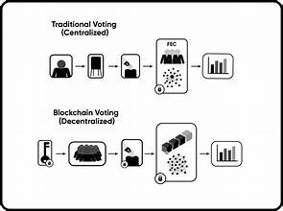

6.2SprintPlanning&Estimation

Sprint Planning:

Sprint planning is the process of selecting and prioritizing the work that will be completed during an upcoming sprint. A sprint is a fixed time frame, typically 2-4 weeks in Scrum, in which a set of user stories or backlog items are developed and delivered. The process involves the following steps:

* Backlog Review: The product owner and team review the product backlog, which contains a list of features, user stories, or tasks. These items are usually prioritized based on value and dependencies.
* Sprint Goal: The product owner defines a sprint goal, which is a high-level objective for the sprint that helps guide the team's work.
* Selection of Work: The team selects a subset of backlog items that can be completed within the sprint. These items become the sprint backlog.
* Task Breakdown: For each item in the sprint backlog, the team breaks down the work into specific tasks or sub-tasks.
* Estimation: The team estimates the effort required to complete each task. This is usually done using techniques like story points, ideal days, or relative sizing.
* Capacity Planning: The team considers its capacity, taking into account factors like team size and availability, to ensure that the selected work can be realistically completed within the sprint.
* Commitment: The team commits to delivering the selected items by the end of the sprint. This commitment is made collectively by the team.

Sprint Estimation:

Estimation is a critical part of sprint planning. It involves assigning a level of effort to each task or user story to provide an understanding of how long it will take to complete. Common estimation techniques in agile include:

* Story Points: Assigning abstract points to user stories based on complexity, effort, and risk. These points provide a relative measure of work.
* Ideal Days: Estimating in terms of ideal working days, where a day represents a consistent amount of effort available for work.
* Planning Poker: A collaborative estimation technique where team members discuss and vote on the effort required for each task or user story.
* Relative Sizing: Comparing the size or effort of one task or user story to another to establish a scale of relative sizing.
* Effective sprint estimation allows the team to:
* Set realistic sprint goals.
* Ensure that the selected work fits within the sprint's capacity.
* Improve predictability by understanding how much work can be completed.
* 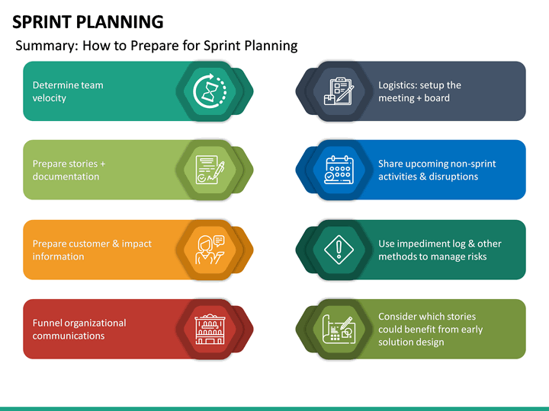Facilitate informed decisions about scope and priorities.

6.3SprintDeliverySchedule

A Sprint Delivery Schedule is a key element of agile project management, particularly in the Scrum framework. It refers to the plan for delivering a set of working features, enhancements, or fixes at the end of a sprint (a fixed time frame, typically 2-4 weeks). The Sprint Delivery Schedule outlines when and how the team will deliver the completed work to stakeholders, including users or the product owner. Here's how it works:

* Sprint Goal: At the beginning of each sprint, a Sprint Goal is defined, describing the high-level objective the team aims to achieve by the end of the sprint. The Sprint Goal guides the team's work during the sprint.
* Backlog Items: The product backlog contains a prioritized list of features, user stories, or tasks. For each sprint, a selection of backlog items is chosen for implementation based on their priority and relevance to the Sprint Goal. These items become the Sprint Backlog.
* Development: The team works on the selected Sprint Backlog items during the sprint. They break down these items into tasks, estimate the effort required, and collaborate to complete them.
* Daily Standups: The team holds daily stand-up meetings to discuss progress, address challenges, and ensure everyone is aligned with the Sprint Goal.
* Quality Assurance: Throughout the sprint, the team conducts testing, quality assurance, and review processes to ensure that the work meets the specified criteria.
* Incremental Development: As features or user stories are completed, they are integrated into the evolving product incrementally. This allows stakeholders to see partial results.
* Review and Demo: At the end of the sprint, the team conducts a Sprint Review, during which the completed work is demonstrated to stakeholders. This provides an opportunity for feedback.
* Retrospective: The team holds a Sprint Retrospective to reflect on what went well, what could be improved, and how to make the next sprint more effective.
* Acceptance and Feedback: Stakeholders review the delivered increment and provide feedback. Based on this feedback, adjustments can be made to the product backlog for the next sprint.
* Delivery: Following the Sprint Review, the team decides whether the work meets the Definition of Done (the agreed-upon quality standards). If it does, the work is delivered to stakeholders.

7. CODING&SOLUTIONING

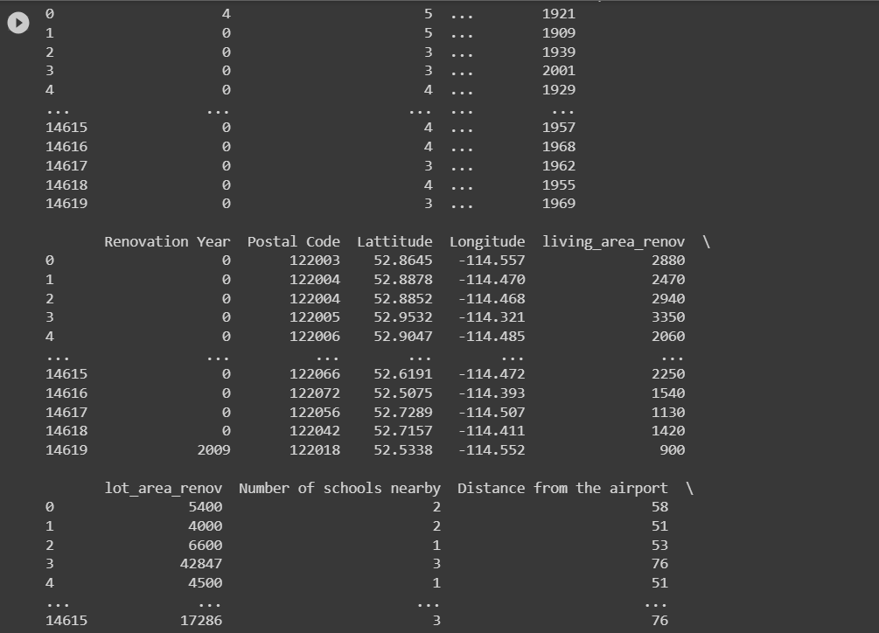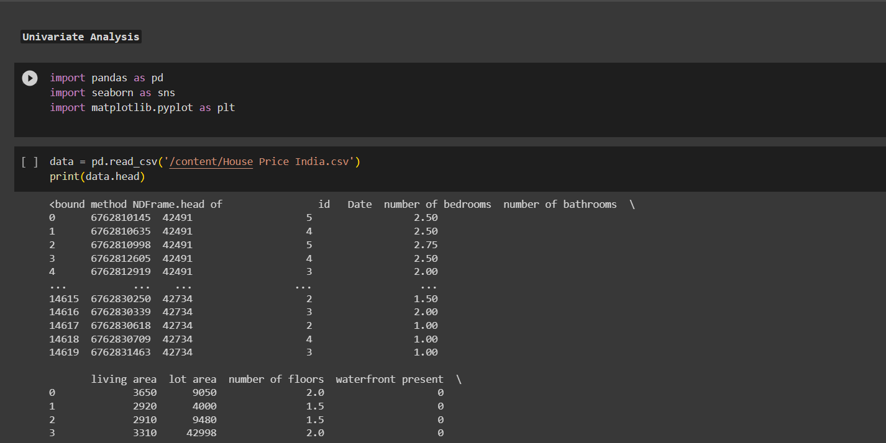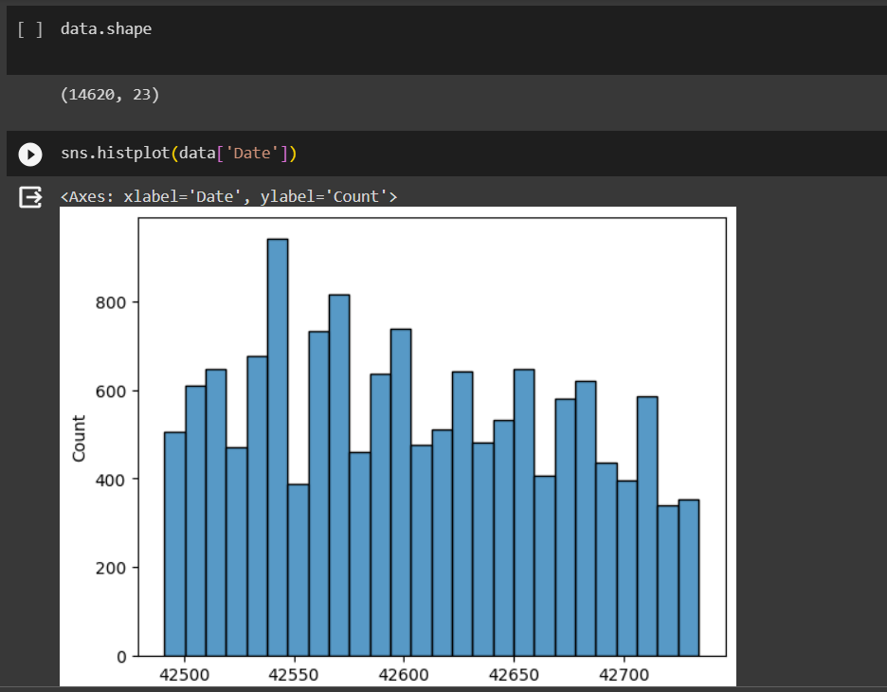

7.1Feature1

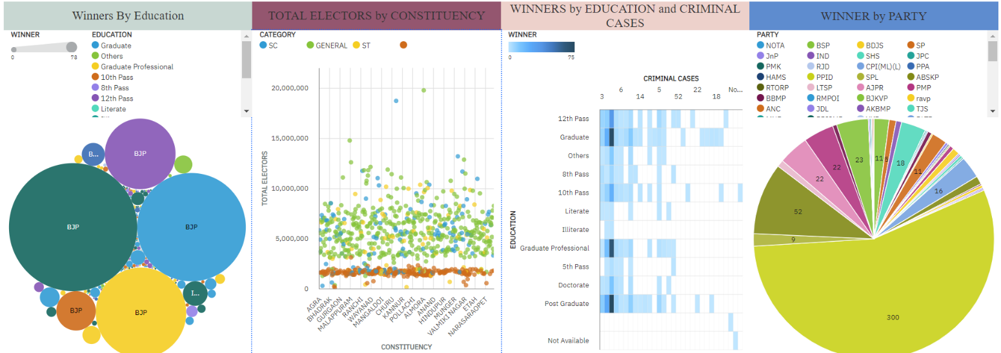

7.2Feature2

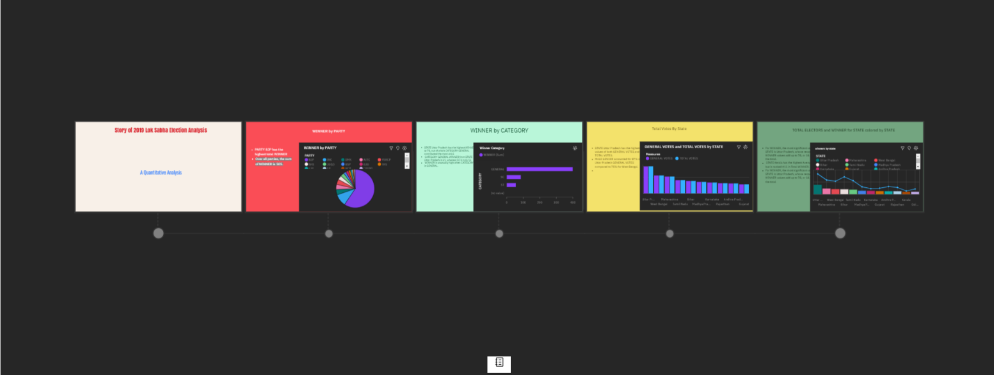

8. PERFORMANCETESTING

Performance testing is a vital phase in software development aimed at assessing how well an application or system performs under different conditions. It involves measuring response times, throughput, resource usage, and identifying potential bottlenecks or scalability issues. By conducting rigorous performance testing, teams can optimize their software, delivering a faster, more responsive, and reliable user experience. This process typically includes defining performance objectives, selecting appropriate testing tools, creating realistic test scenarios, analyzing results, and fine-tuning the application to meet desired performance metrics. Continuous performance testing is also essential to ensure that performance remains robust as the software evolves.

8.1PerformaceMetrics

**import numpy as np import pandas as pd**

**import matplotlib.pyplot as plt**

**import matplotlib.animation as animation import seaborn as sns**

[ ]:

[ ]:

[ ]:

[ ]:

df = pd.read_csv('/content/House Price India.csv')

df.head()

\

|  |  |  |  |  |
| --- | --- | --- | --- | --- |
| 0 | 52.8645 | -114.557 | 2880 | 5400 |
| 1 | 52.8878 | -114.470 | 2470 | 4000 |
| 2 | 52.8852 | -114.468 | 2940 | 6600 |
| 3 | 52.9532 | -114.321 | 3350 | 42847 |
| 4 | 52.9047 | -114.485 | 2060 | 4500 |

condition of the house … Built Year Renovation Year Postal Code \

|  |  |  |  |  |
| --- | --- | --- | --- | --- |
| 0 | 9050 | 2.0 | 0 | 4 |
| 1 | 4000 | 1.5 | 0 | 0 |
| 2 | 9480 | 1.5 | 0 | 0 |
| 3 | 42998 | 2.0 | 0 | 0 |
| 4 | 4500 | 1.5 | 0 | 0 |

|  |  |  |  |
| --- | --- | --- | --- |
| id Date number of bedrooms number of bathrooms living area | | | |
| 0 6762810145 42491 | 5 | 2.50 | 3650 |
| 1 6762810635 42491 | 4 | 2.50 | 2920 |
| 2 6762810998 42491 | 5 | 2.75 | 2910 |
| 3 6762812605 42491 | 4 | 2.50 | 3310 |
| 4 6762812919 42491 | 3 | 2.00 | 2710 |
| lot area number of floors | waterfront present number of views \ | | |

0 5 … 1921 0 122003

1 5 … 1909 0 122004

2 3 … 1939 0 122004

3 3 … 2001 0 122005

4 4 … 1929 0 122006

Lattitude Longitude living_area_renov lot_area_renov \

Number of schools nearby Distance from the airport Price

|  |  |  |
| --- | --- | --- |
| 0 | 2 | 58 2380000 |
| 1 | 2 | 51 1400000 |
| 2 | 1 | 53 1200000 |
| 3 | 3 | 76 838000 |
| 4  [5 rows x 23 columns] | 1 | 51 805000 |

[ ]:

df.describe()

|  |  |  |  |  |  |  |  |  |  |  |
| --- | --- | --- | --- | --- | --- | --- | --- | --- | --- | --- |
| [ | ]: | id | number of bedrooms number | | | of bathrooms | | | living area | \ |
|  | count | 1.462000e+04 | 14620.000000 | | | 14620.000000 | | | 14620.000000 |  |
|  | mean | 6.762821e+09 | 3.379343 | | | 2.129583 | | | 2098.262996 |  |
|  | std | 6.237575e+03 | 0.938719 | | | 0.769934 | | | 928.275721 |  |
|  | min | 6.762810e+09 | 1.000000 | | | 0.500000 | | | 370.000000 |  |
|  | 25% | 6.762815e+09 | 3.000000 | | | 1.750000 | | | 1440.000000 |  |
|  | 50% | 6.762821e+09 | 3.000000 | | | 2.250000 | | | 1930.000000 |  |
|  | 75% | 6.762826e+09 | 4.000000 | | | 2.500000 | | | 2570.000000 |  |
|  | max | 6.762832e+09 | 33.000000 | | | 8.000000 | | | 13540.000000 |  |
| lot area number of floors waterfront present number of views \ | | | | | | | | | | |
| count | | 1.462000e+04 | 14620.000000 | | 14620.000000 | | | | 14620.000000 | |
| mean | | 1.509328e+04 | 1.502360 | | 0.007661 | | | | 0.233105 | |
| std | | 3.791962e+04 | 0.540239 | | 0.087193 | | | | 0.766259 | |
| min | | 5.200000e+02 | 1.000000 | | 0.000000 | | | | 0.000000 | |
| 25% | | 5.010750e+03 | 1.000000 | | 0.000000 | | | | 0.000000 | |
| 50% | | 7.620000e+03 | 1.500000 | | 0.000000 | | | | 0.000000 | |
| 75% | | 1.080000e+04 | 2.000000 | | 0.000000 | | | | 0.000000 | |
| max | | 1.074218e+06 | 3.500000 | | 1.000000 | | | | 4.000000 | |
| condition of the house grade of the house … Built Year \ | | | | | | | | | | |
| count | | 14620.000000 | | | 14620.000000 | | … | 14620.000000 | | |
| mean | | 3.430506 | | | 7.682421 | | … | 1970.926402 | | |
| std | | 0.664151 | | | 1.175033 | | … | 29.493625 | | |
| min | | 1.000000 | | | 4.000000 | | … | 1900.000000 | | |
| 25% | | 3.000000 | | | 7.000000 | | … | 1951.000000 | | |
| 50% | | 3.000000 | | | 7.000000 | | … | 1975.000000 | | |
| 75% | | 4.000000 | | | 8.000000 | | … | 1997.000000 | | |
| max | | 5.000000 | | | 13.000000 | | … | 2015.000000 | | |
|  | | Renovation Year | | Postal Code | Lattitude | | Longitude \ | | | |
| count | | 14620.000000 | | 14620.000000 | 14620.000000 | | 14620.000000 | | | |
| mean | | 90.924008 | | 122033.062244 | 52.792848 | | -114.404007 | | | |
| std | | 416.216661 | | 19.082418 | 0.137522 | | 0.141326 | | | |
| min | | 0.000000 | | 122003.000000 | 52.385900 | | -114.709000 | | | |

|  |  |  |  |  |  |  |
| --- | --- | --- | --- | --- | --- | --- |
| 25% | 0.000000 122017.000000 | | 52.707600 | | -114.519000 | |
| 50% | 0.000000 122032.000000 | | 52.806400 | | -114.421000 | |
| 75% | 0.000000 122048.000000 | | 52.908900 | | -114.315000 | |
| max | 2015.000000 122072.000000 | | 53.007600 | | -113.505000 | |
|  | living_area_renov | lot_area_renov | Number | of | schools nearby | \ |
| count | 14620.000000 | 14620.000000 |  |  | 14620.000000 |  |
| mean | 1996.702257 | 12753.500068 |  |  | 2.012244 |  |
| std | 691.093366 | 26058.414467 |  |  | 0.817284 |  |
| min | 460.000000 | 651.000000 |  |  | 1.000000 |  |
| 25% | 1490.000000 | 5097.750000 |  |  | 1.000000 |  |
| 50% | 1850.000000 | 7620.000000 |  |  | 2.000000 |  |
| 75% | 2380.000000 | 10125.000000 |  |  | 3.000000 |  |
| max | 6110.000000 | 560617.000000 |  |  | 3.000000 |  |

Distance from the airport Price

|  |  |  |
| --- | --- | --- |
| count | 14620.000000 | 1.462000e+04 |
| mean | 64.950958 | 5.389322e+05 |
| std | 8.936008 | 3.675324e+05 |
| min | 50.000000 | 7.800000e+04 |
| 25% | 57.000000 | 3.200000e+05 |
| 50% | 65.000000 | 4.500000e+05 |
| 75% | 73.000000 | 6.450000e+05 |
| max | 80.000000 | 7.700000e+06 |

[8 rows x 22 columns]

[ ]:

df.shape

[ ]: (14620, 23)

# DATA CLEANING

[ ]:

df.dropna(inplace = **True**)

[ ]:

print(df.duplicated())

1. False
2. False
3. False
4. False
5. False

…

14615 False

14616 False

14617 False

14618 False

14619 False

Length: 14620, dtype: bool

[ ]:

df.drop_duplicates(inplace = **True**)

[ ]:

df['Date'] = pd.to_datetime(df['Date'])

[ ]:

df.head()

[ ]: id Date number of bedrooms \

|  |  |
| --- | --- |
| 0 6762810145 1970-01-01 00:00:00.000042491 | 5 |
| 1 6762810635 1970-01-01 00:00:00.000042491 | 4 |
| 2 6762810998 1970-01-01 00:00:00.000042491 | 5 |
| 3 6762812605 1970-01-01 00:00:00.000042491 | 4 |
| 4 6762812919 1970-01-01 00:00:00.000042491 | 3 |

number of bathrooms living area lot area number of floors \

0 2.50 3650 9050 2.0

1 2.50 2920 4000 1.5

|  |  |  |  |  |  |  |  |
| --- | --- | --- | --- | --- | --- | --- | --- |
| 2 | 2.75 | 2910 | 9480 | 1.5 | | | |
| 3 | 2.50 | 3310 | 42998 | 2.0 | | | |
| 4 | 2.00 | 2710 | 4500 | 1.5 | | | |
| waterfront present | | number of views | condition | of the | house | … | \ |
| 0 0 | | 4 |  |  | 5 | … |  |
| 1 0 | | 0 |  |  | 5 | … |  |
| 2 0 | | 0 |  |  | 3 | … |  |
| 3 0 | | 0 |  |  | 3 | … |  |
| 4 0 | | 0 |  |  | 4 | … |  |
| Built Year Renovation Year Postal Code Lattitude Longitude \ | | | | | | | |

|  |  |  |  |  |  |
| --- | --- | --- | --- | --- | --- |
| 0 | 1921 | 0 | | 122003 52.8645 -114.557 | |
| 1 | 1909 | 0 | | 122004 52.8878 -114.470 | |
| 2 | 1939 | 0 | | 122004 52.8852 -114.468 | |
| 3 | 2001 | 0 | | 122005 52.9532 -114.321 | |
| 4 | 1929 | 0 | | 122006 52.9047 -114.485 | |
| living_area_renov lot_area_renov Number of schools nearby \ | | | | | |
| 0 | 2880 | | 5400 | | 2 |
| 1 | 2470 | | 4000 | | 2 |
| 2 | 2940 | | 6600 | | 1 |
| 3 | 3350 | | 42847 | | 3 |
| 4 | 2060 | | 4500 | | 1 |
| Distance from the | | | airport Price | | |
| 0 | | | 58 2380000 | | |
| 1 | | | 51 1400000 | | |
| 2 | | | 53 1200000 | | |

|  |  |  |
| --- | --- | --- |
| 3 | 76 | 838000 |
| 4  [5 rows x 23 columns] | 51 | 805000 |

[ ]:

df['Date'] = df['Date'].dt.date

[ ]:

df.head()

[ ]: id Date number of bedrooms number of bathrooms \

|  |  |  |  |  |  |
| --- | --- | --- | --- | --- | --- |
| 0 6762810145 | | 1970-01-01 | 5 | | 2.50 |
| 1 6762810635 | | 1970-01-01 | 4 | | 2.50 |
| 2 6762810998 | | 1970-01-01 | 5 | | 2.75 |
| 3 6762812605 | | 1970-01-01 | 4 | | 2.50 |
| 4 6762812919 | | 1970-01-01 | 3 | | 2.00 |
| living area | | lot area number | of floors waterfront present \ | | |
| 0 | 3650 | 9050 | 2.0 | 0 | |
| 1 | 2920 | 4000 | 1.5 | 0 | |
| 2 | 2910 | 9480 | 1.5 | 0 | |
| 3 | 3310 | 42998 | 2.0 | 0 | |
| 4 | 2710 | 4500 | 1.5 | 0 | |

number of views condition of the house … Built Year Renovation Year \

0 4 5 … 1921 0

1 0 5 … 1909 0

2 0 3 … 1939 0

3 0 3 … 2001 0

4 0 4 … 1929 0

Postal Code Lattitude Longitude living_area_renov lot_area_renov \

0 122003 52.8645 -114.557 2880 5400

1 122004 52.8878 -114.470 2470 4000

2 122004 52.8852 -114.468 2940 6600

3 122005 52.9532 -114.321 3350 42847

4 122006 52.9047 -114.485 2060 4500

|  |  |  |  |
| --- | --- | --- | --- |
|  | Number of schools nearby Distance from the | airport | Price |
| 0 | 2 | 58 | 2380000 |
| 1 | 2 | 51 | 1400000 |
| 2 | 1 | 53 | 1200000 |
| 3 | 3 | 76 | 838000 |
| 4 | 1 | 51 | 805000 |
| [5 | rows x 23 columns] |  |  |

# UNIVARIATE

[ ]:

df['Price'].plot.hist() plt.xlabel('Price') plt.title('Price Distribution') plt.show()

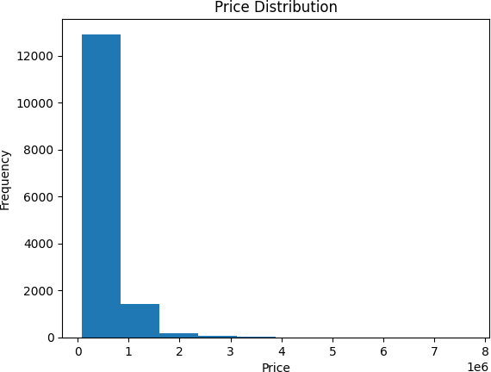

[ ]:

df['number of bedrooms'].value_counts().plot(kind='bar') plt.xlabel('Number of Bedrooms')

plt.ylabel('Count') plt.title('Bedroom Count') plt.show()

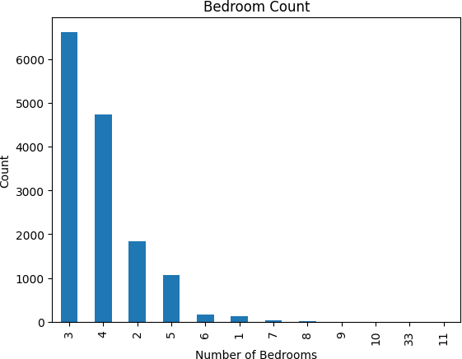

# BI-VARIATE

[ ]:

plt.scatter(df['living area'], df['Price']) plt.xlabel('Living Area') plt.ylabel('Price')

plt.title('Scatter Plot: Living Area vs. Price') plt.show()

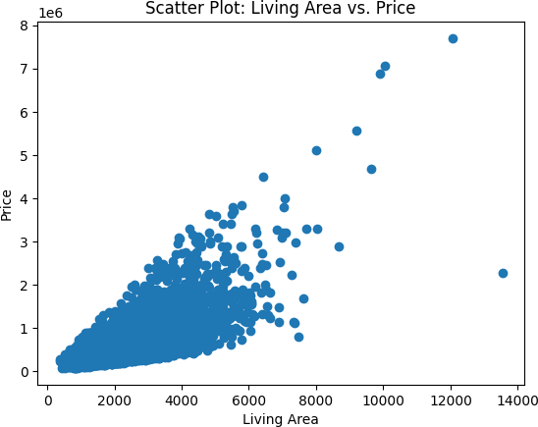

[ ]:

sns.boxplot(x='number of bedrooms', y='Price', data=df) plt.xlabel('Number of Bedrooms')

plt.ylabel('Price')

plt.title('Box Plot: Price by Number of Bedrooms') plt.show()

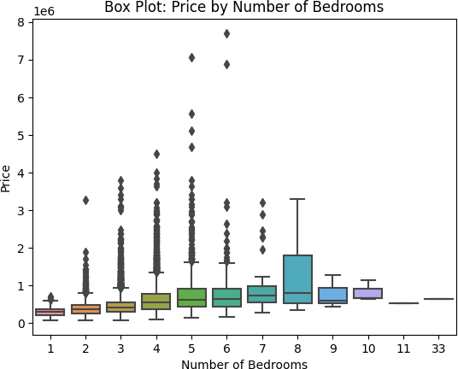

# Multivariate

[ ]:

correlation_matrix = df.corr() sns.heatmap(correlation_matrix, annot=**True**, cmap='coolwarm') plt.title('Correlation Heatmap')

plt.show()

<ipython-input-40-182fd031f822>:1: FutureWarning: The default value of numeric_only in DataFrame.corr is deprecated. In a future version, it will default to False. Select only valid columns or specify the value of numeric_only to silence this warning.

correlation_matrix = df.corr()

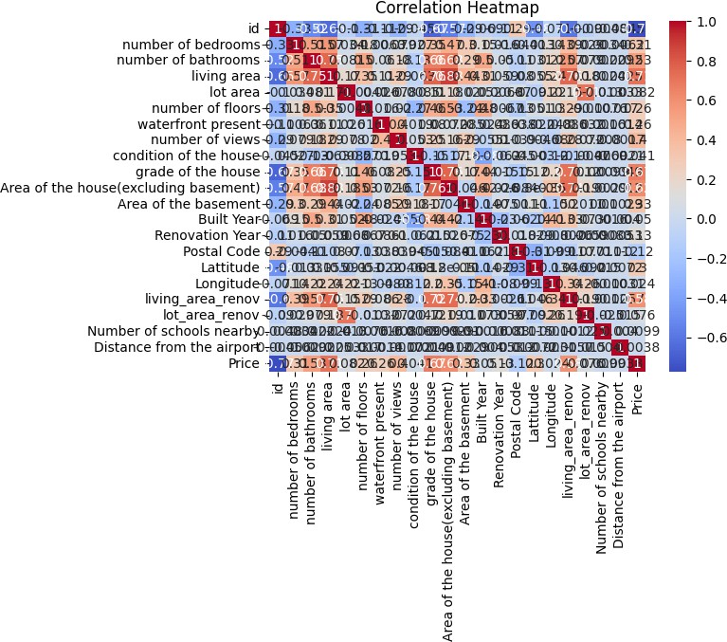

[ ]:

sns.pairplot(df[['Price', 'living area', 'number of bedrooms', 'number of␣

𝗌bathrooms']])

plt.title('Pair Plot') plt.show()

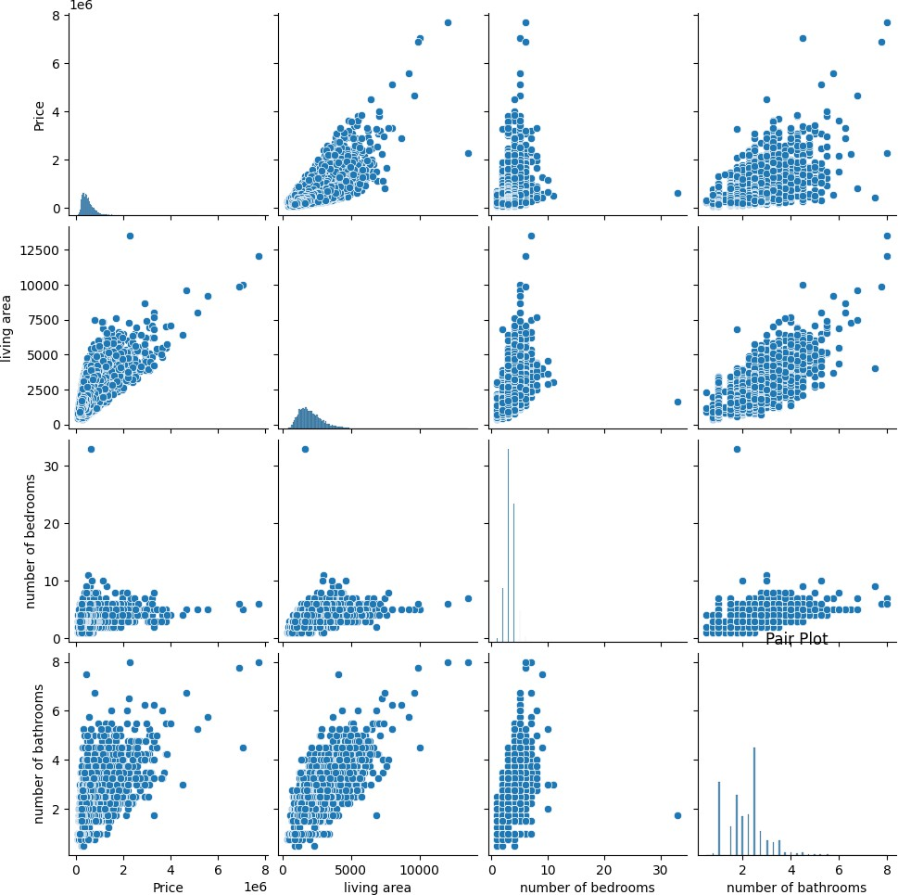

# DESCRIPTIVE STATISTICS

[ ]:

*#Basic Summary Statistics for Numerical Columns:*

descriptive_stats = df.describe()

[ ]:

*#Count of Non-null Values:* non_null_counts = df.count() non_null_counts

[ ]: id 14620

Date 14620

number of bedrooms 14620

number of bathrooms 14620

|  |  |  |
| --- | --- | --- |
| living area |  | 14620 |
| lot area |  | 14620 |
| number of floors |  | 14620 |
| waterfront present |  | 14620 |
| number of views |  | 14620 |
| condition of the house |  | 14620 |
| grade of the house |  | 14620 |
| Area of the house(excluding | basement) | 14620 |
| Area of the basement |  | 14620 |
| Built Year |  | 14620 |
| Renovation Year |  | 14620 |
| Postal Code |  | 14620 |
| Lattitude |  | 14620 |
| Longitude |  | 14620 |
| living_area_renov |  | 14620 |
| lot_area_renov |  | 14620 |
| Number of schools nearby |  | 14620 |
| Distance from the airport |  | 14620 |
| Price |  | 14620 |
| dtype: int64 |  |  |

[ ]:

*#Frequency Count for Categorical Columns:*

bedroom_counts = df['number of bedrooms'].value_counts() bedroom_counts

[ ]: 3 6612

4 4724

2 1844

5 1079

6 176

1 136

7 30

8 11

9 3

10 3

33 1

11 1

Name: number of bedrooms, dtype: int64

[ ]:

*#Grouping and Aggregating:*

avg_price_by_bedrooms = df.groupby('number of bedrooms')['Price'].mean() avg_price_by_bedrooms

[ ]: number of bedrooms

1 3.089638e+05

2 3.985476e+05

3 4.632776e+05

[ ]:

[ ]:

[ ]:

[ ]:

[ ]:

[ ]:

4 6.361988e+05

5 7.752550e+05

6 8.375815e+05

7 1.016544e+06

8 1.208455e+06

9 7.766663e+05

10 8.200000e+05

11 5.200000e+05

33 6.400000e+05

Name: Price, dtype: float64

9.RESULTS

9.1OutputScreenshots

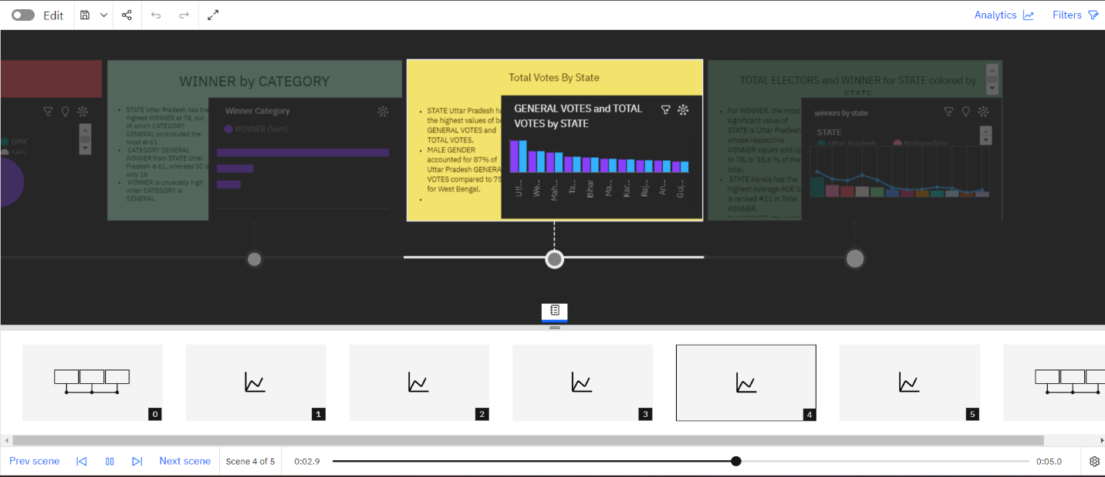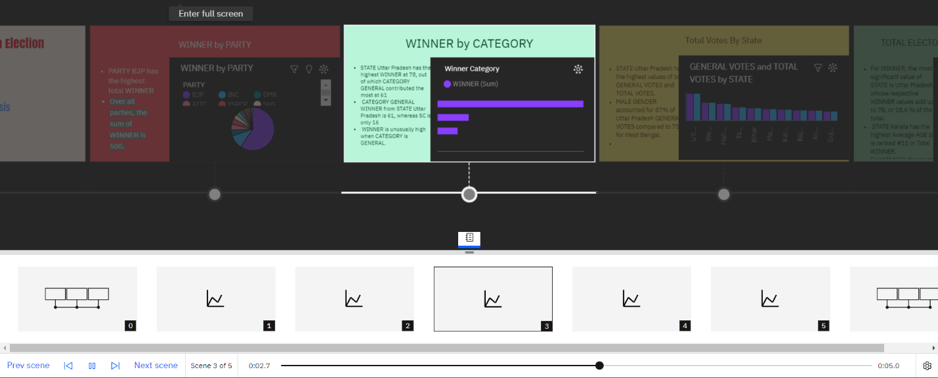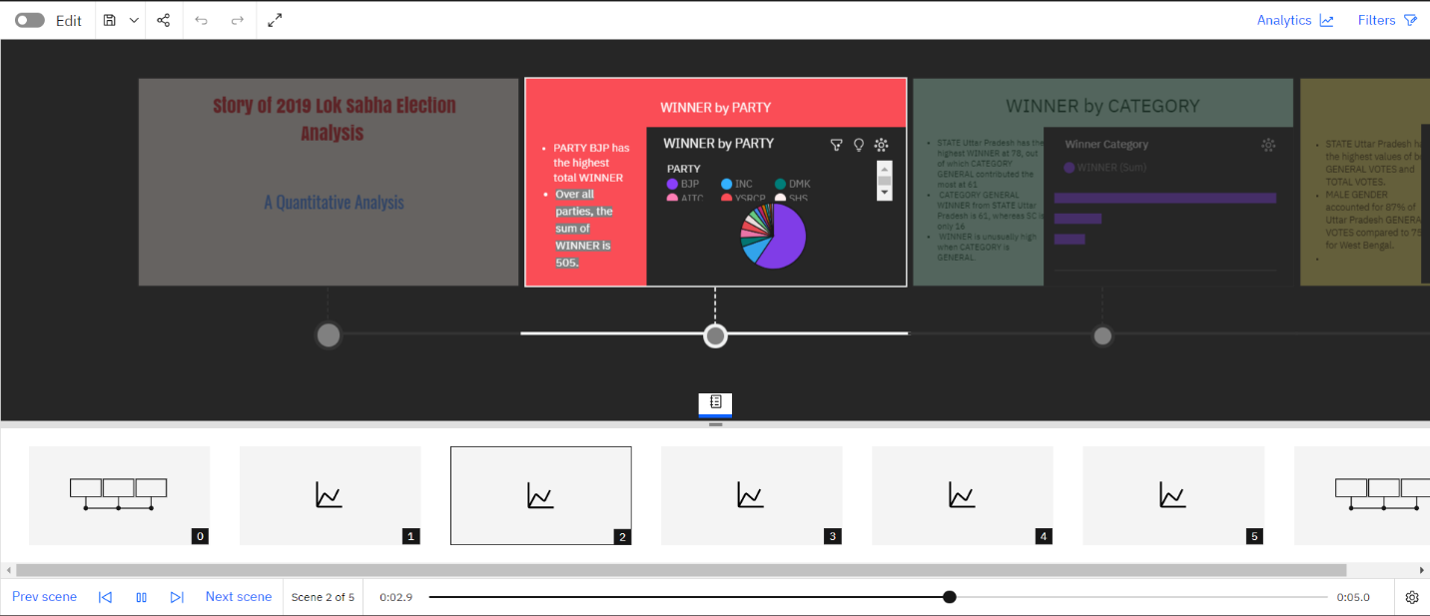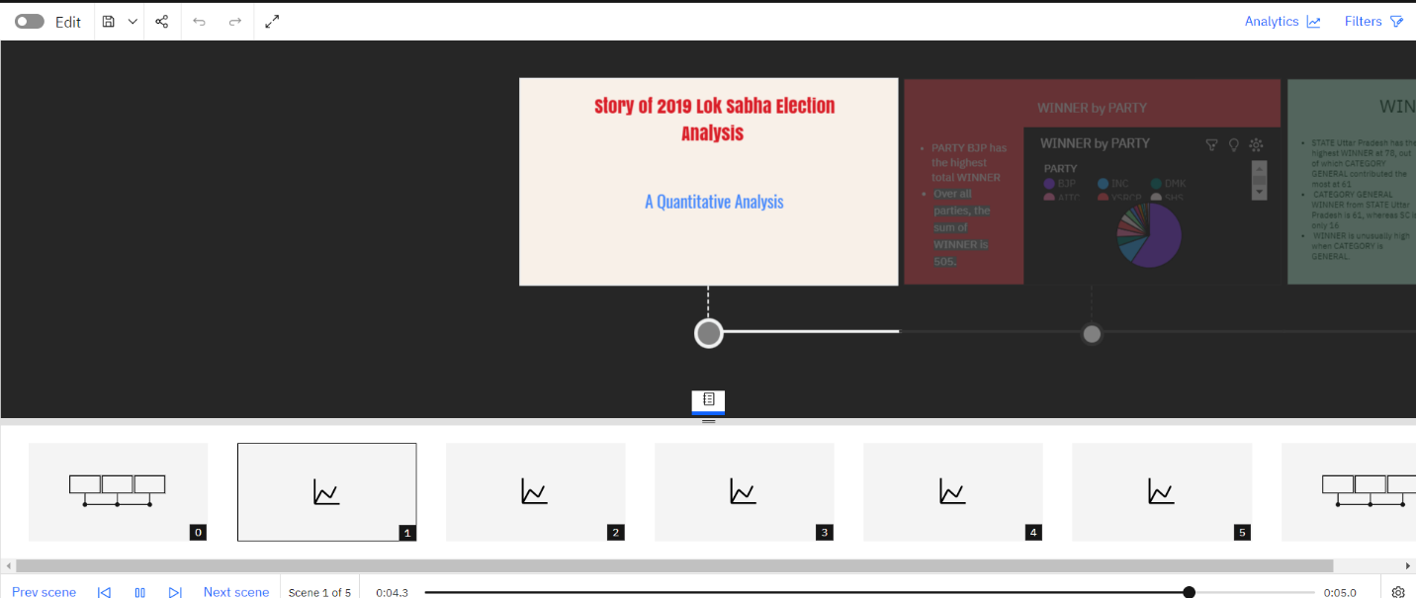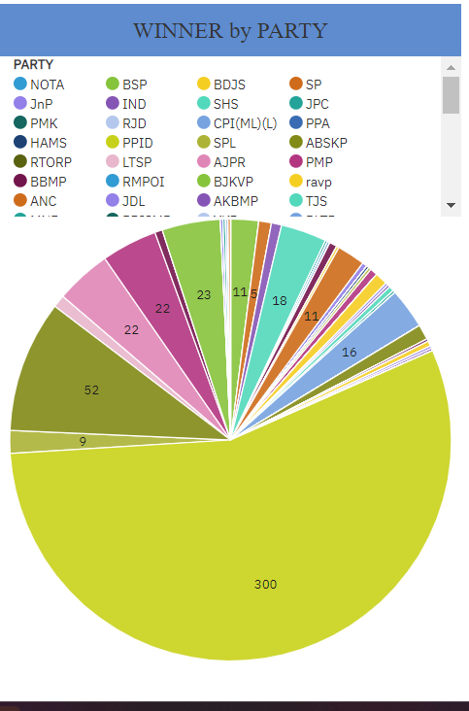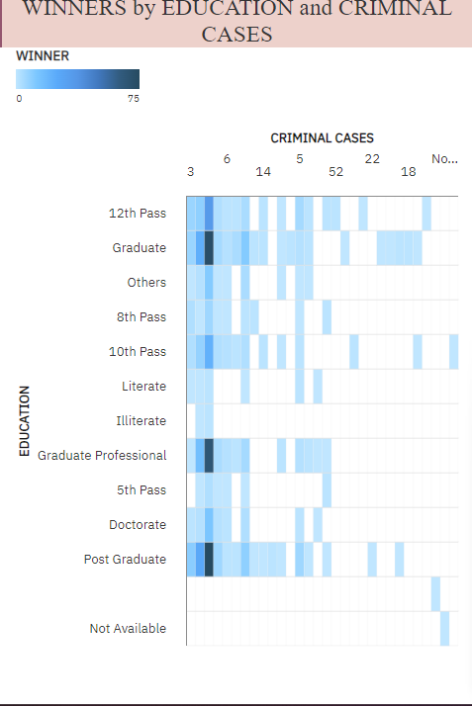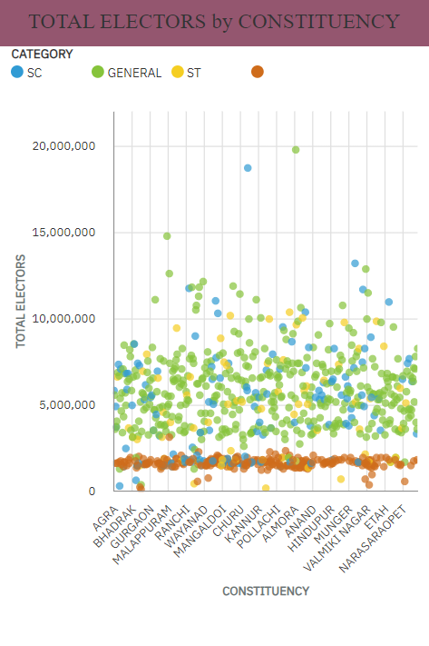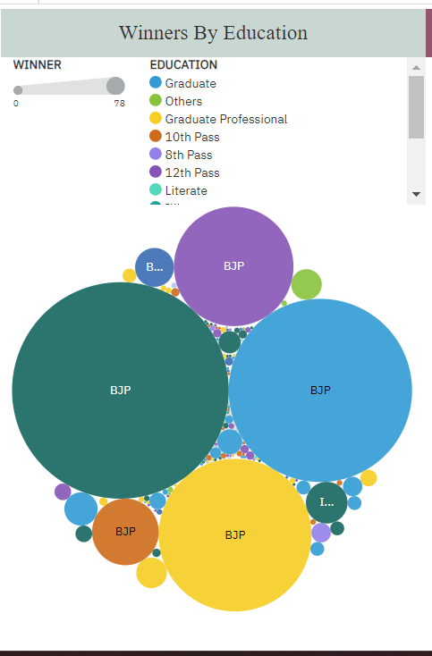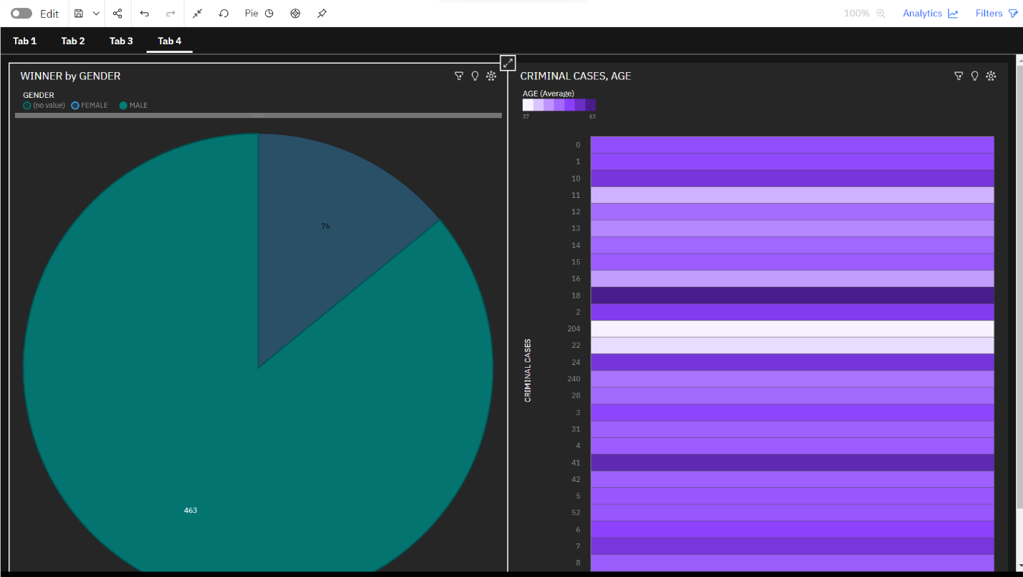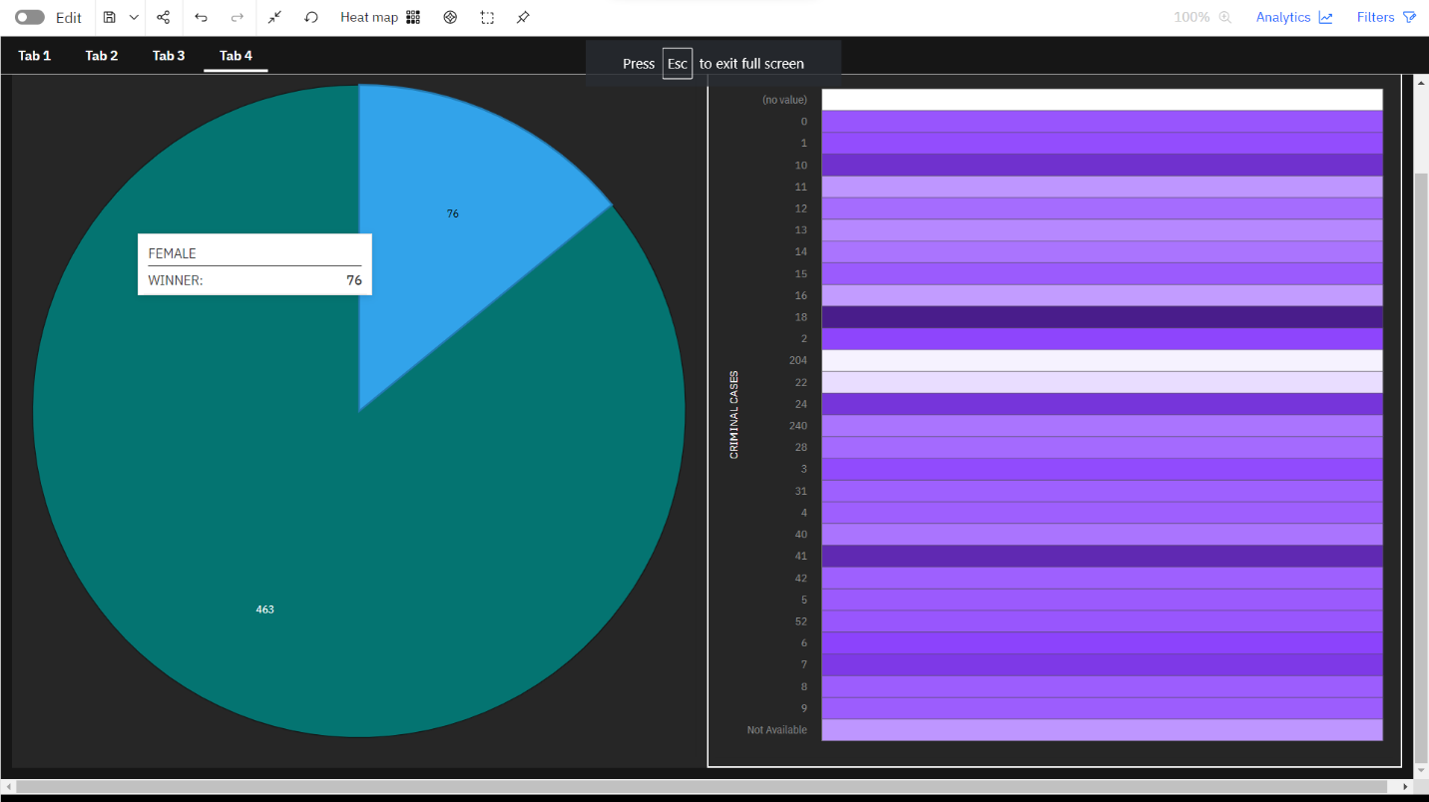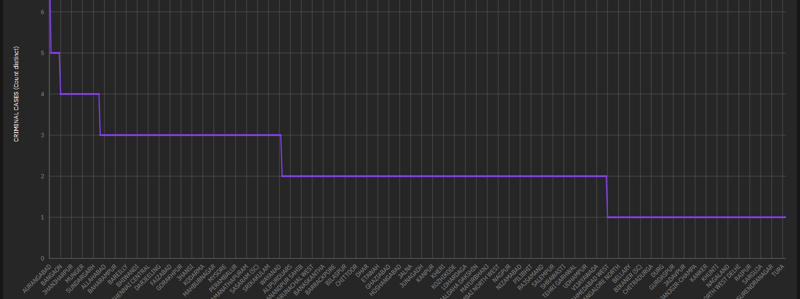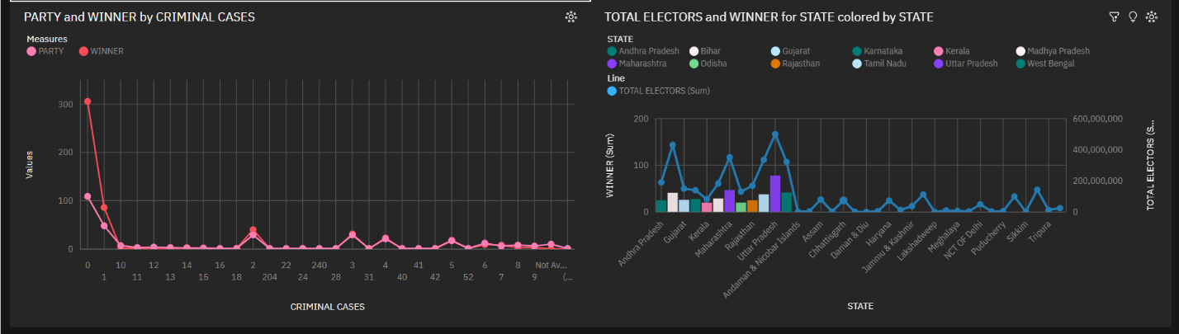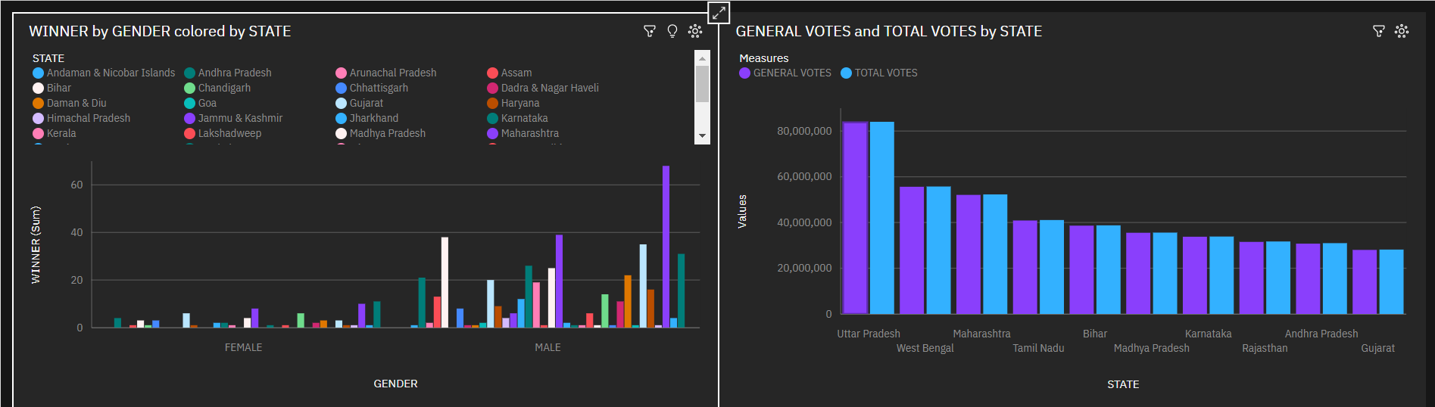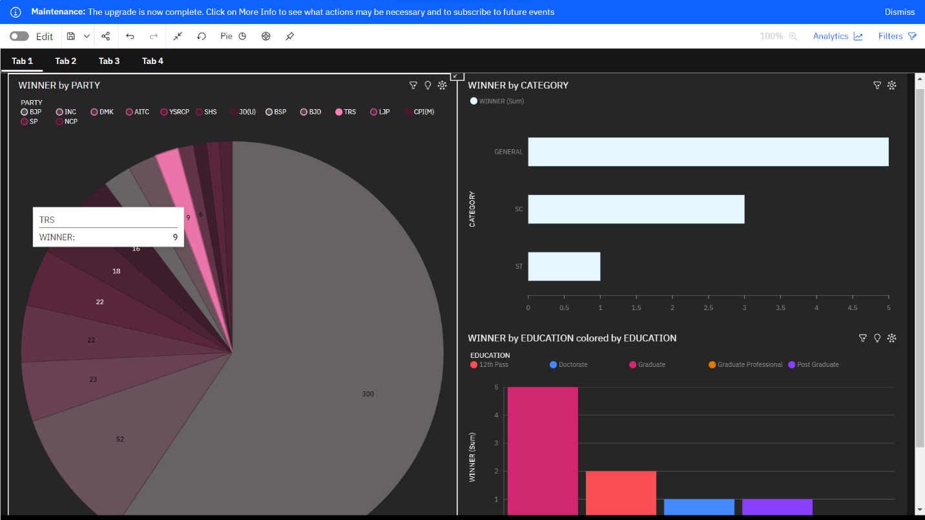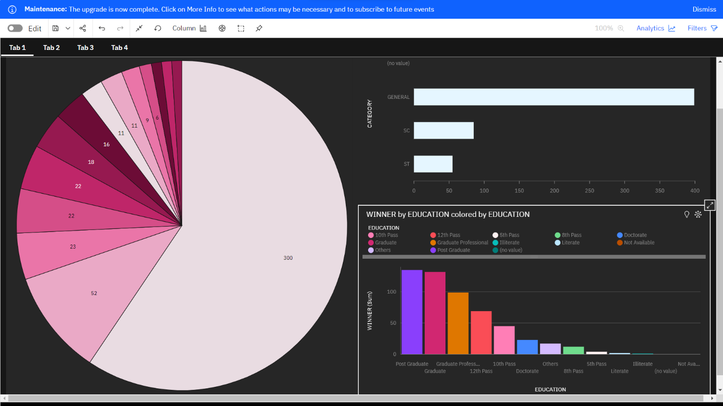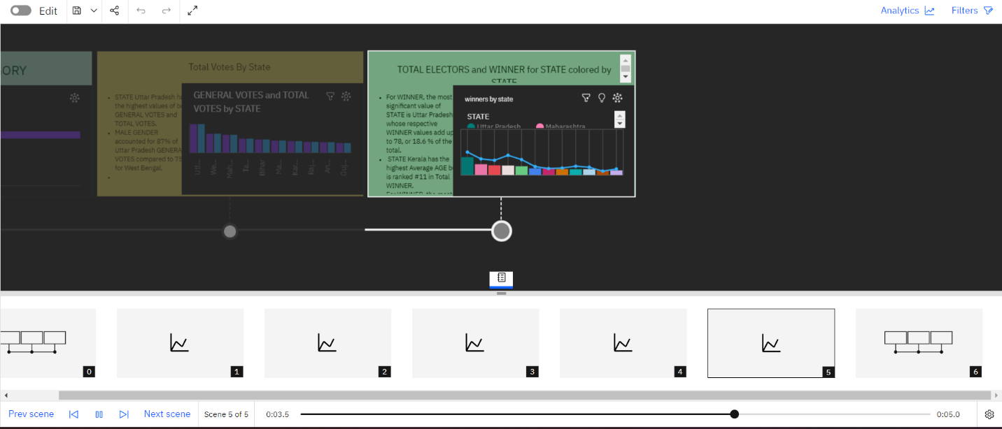

10.ADVANTAGES&DISADVANTAGES

Advantages:

* Data-Driven Insights: Quantitative analysis provides data-driven insights into various aspects of the election process, including candidate performance, voter behavior, and electoral trends.
* Objective and Reproducible: Quantitative analysis is often more objective and reproducible than qualitative methods, making it a valuable tool for research and decision-making.
* Large-Scale Data Handling: It allows for the handling of large volumes of data, which is essential in a national election with millions of voters and numerous candidates.
* Comparative Analysis: Researchers can conduct comparative analysis of candidates and constituencies, aiding in identifying patterns and trends.
* Informed Decision-Making: Political candidates can make informed decisions regarding campaign strategies, resource allocation, and messaging by relying on data-driven insights.
* Predictive Modeling: Quantitative analysis can support predictive modeling to forecast election outcomes, helping candidates and parties plan accordingly.

Disadvantages:

* Data Limitations: The quality of quantitative analysis heavily relies on the quality of the available data, and in some cases, data may be incomplete or biased.
* Overemphasis on Numbers: Relying solely on quantitative analysis may lead to an overemphasis on numbers and statistics, potentially overlooking the human and contextual factors that influence elections.
* Ethical Concerns: There are ethical concerns related to the use of data in election campaigns, including issues of privacy, data protection, and the potential for misuse.
* Complex Methodologies: Conducting quantitative analysis often requires advanced statistical and data analysis skills, which may not be readily available to all researchers and candidates.
* Limited Contextual Understanding: Purely quantitative analysis may lack the depth of contextual understanding that can be gained through qualitative methods, such as interviews and fieldwork.
* Challenges in Real-Time Adaptation: While quantitative data can inform campaign strategies, there may be challenges in real-time adaptation to rapidly changing voter sentiments and issues.

11. Conclusion

The quantitative analysis of candidates in the 2019 Lok Sabha Elections has yielded valuable insights into the dynamics of one of the world's largest democratic exercises. Through a data-driven approach, this study aimed to shed light on various facets of the electoral process, candidate strategies, and voter behaviors. The following key conclusions emerge from the research:

1. Data-Driven Campaigning:

The 2019 Lok Sabha Elections witnessed a significant shift towards data-driven campaigning. Political candidates increasingly leveraged quantitative analysis to target specific voter segments, refine campaign messages, and allocate resources effectively. This transition reflects the growing importance of data in political strategy.

2. Voter Demographics and Behavior:

Analysis of voter demographics and behavior revealed the diversity and complexity of the Indian electorate. Data-driven insights provided a deeper understanding of voter preferences, socio-economic factors influencing voting choices, and regional variations. This knowledge is pivotal for tailoring campaign strategies.

3. Voter Sentiment and Issues:

Real-time polling data and public opinion trends allowed candidates to stay attuned to evolving voter sentiment and emerging issues. Candidates who adapted to changing voter concerns demonstrated a higher degree of campaign responsiveness.

4. Empathy-Driven Campaigns:

Empathy for the concerns of constituents played a central role in candidate strategies. Data analytics and quantitative insights served as tools for empathetic representation, enabling candidates to align their agendas with the needs of the electorate.

5. Challenges and Future Directions:

Despite the advantages of data-driven campaigning, several challenges persist. Ethical data use, privacy concerns, and the need for real-time adaptability pose ongoing dilemmas. Future research should address these challenges and explore innovative methods to harness data effectively.

In conclusion, the 2019 Lok Sabha Elections marked a significant turning point in the use of quantitative analysis and data-driven decision-making in Indian politics. Candidates who embraced this shift were better equipped to connect with voters, address their concerns, and adapt to the rapidly changing electoral landscape. As India continues to evolve politically, the role of quantitative analysis in shaping electoral outcomes is set to grow, making it a critical tool for candidates and parties in the coming years.

12. FUTURESCOPE

The future scope of quantitative analysis in the context of studying candidates in elections, such as the Lok Sabha Elections, is promising and continues to evolve with advances in data analytics and technology. Here are some future directions and opportunities:

* Advanced Data Analytics: The use of advanced data analytics, including machine learning and artificial intelligence, will become more prevalent in analyzing election data. Predictive modeling will be refined to provide more accurate forecasts of election outcomes.
* Real-Time Monitoring: With the increasing availability of real-time data, candidates and political parties can monitor voter sentiment, campaign performance, and emerging issues on a daily or even hourly basis. This enables agile decision-making during the election period.
* Microtargeting: Quantitative analysis will continue to refine microtargeting strategies, allowing candidates to tailor campaign messages and outreach to highly specific demographics and voter segments.
* Ethical Data Use: As ethical concerns related to data use in politics grow, future developments will focus on ensuring transparency, privacy protection, and responsible data handling in election campaigns.
* Social Media Analysis: Social media platforms play a significant role in modern campaigns. The future scope includes more sophisticated social media data analysis to gauge public sentiment, identify trends, and address fake news and disinformation.
* Integration of Multiple Data Sources: Integration of various data sources, such as voter databases, social media data, and polling data, will offer a more comprehensive view of voter behavior and preferences.
* Voter Engagement: Quantitative analysis can be used to develop strategies for increasing voter engagement and turnout, especially among younger demographics.
* Enhanced Data Visualization: Data visualization tools will continue to improve, making complex data more accessible and understandable for candidates, campaign teams, and the general public.
* Cross-Channel Analysis: Analyzing data from multiple channels, including online and offline interactions, will be crucial for understanding the full scope of election campaigns and voter engagement.
* International Best Practices: Learning from the best practices of quantitative analysis in elections from around the world will contribute to the development of more effective strategies in India's electoral landscape.
* Crisis Management: Candidates and parties can use quantitative analysis to predict and manage potential campaign crises, responding promptly to emerging issues.
* Customized Campaign Software: The development of customized campaign management software and tools tailored to the specific needs of Indian elections will offer significant advantages to candidates and parties.
* Research and Academia: The future scope includes more academic research on the impact of quantitative analysis in politics, leading to a deeper understanding of its benefits and limitations.

13. APPENDIX

* An "Appendix" is a supplementary section of a research project, report, or paper where you include additional information that supports or complements the main content but is not essential to the primary narrative. The content you place in the appendix is often material that might be lengthy, detailed, or tangential to the central argument or findings. Here are some common items you can include in an appendix for a quantitative analysis of candidates in the 2019 Lok Sabha Elections:
* Data Tables: Large data tables, spreadsheets, or datasets that you referenced in your analysis can be placed in the appendix to avoid clutter in the main body of the text.
* Graphs and Charts: Complex graphs, charts, or visual representations of data that support your findings can be included in the appendix.
* Survey Questionnaires: If you conducted surveys or collected data through questionnaires, you can place the full survey instruments in the appendix for reference.
* Statistical Models: Detailed descriptions of the statistical models, formulas, or algorithms you used in your analysis can be included in the appendix for those interested in the technical aspects of your research.
* Additional Figures: Supplementary figures or images that provide more context or visual representations of your data can be placed in the appendix.
* Code Samples: If you used programming code for data analysis or data visualization, you can include relevant code snippets in the appendix.
* Additional Methodological Details: Elaborate on your research methodology, including detailed explanations of data collection processes, statistical tests, and any assumptions made.
* Extended Literature Review: If your research includes a comprehensive literature review, you can place a more extensive version with additional references in the appendix.
* Glossary: If you use specialized terms or acronyms, provide a glossary to help readers understand the terminology.
* Additional Survey Data: In case you collected a substantial amount of survey data, consider placing subsets of data in the appendix, especially if you only presented summarized findings in the main text.
* Supporting Documents: Any supplementary documents, reports, or sources that contributed to your research can be included in the appendix for reference.
* Informed Consent Forms: If human subjects were involved in your research, include copies of informed consent forms in the appendix to demonstrate ethical research practices.
* Maps: Detailed maps that provide geographical context for your research, such as constituency boundaries or electoral district maps.

SourceCode

<!DOCTYPE html>

<html lang="en">

<head>

<meta charset="utf-8">

<meta content="width=device-width, initial-scale=1.0" name="viewport">

<title>Reveal Bootstrap Temp</title>

<meta content="" name="description">

<meta content="" name="keywords">

<!-- Favicons -->

<link href="assets/img/favicon.png" rel="icon">

<link href="assets/img/apple-touch-icon.png" rel="apple-touch-icon">

<!-- Google Fonts -->

<link href="https://fonts.googleapis.com/css?family=Open+Sans:300,300i,400,400i,700,700i|Raleway:300,400,500,700,800|Montserrat:300,400,700" rel="stylesheet">

<!-- Vendor CSS Files -->

<link href="assets/vendor/aos/aos.css" rel="stylesheet">

<link href="assets/vendor/bootstrap/css/bootstrap.min.css" rel="stylesheet">

<link href="assets/vendor/bootstrap-icons/bootstrap-icons.css" rel="stylesheet">

<link href="assets/vendor/boxicons/css/boxicons.min.css" rel="stylesheet">

<link href="assets/vendor/glightbox/css/glightbox.min.css" rel="stylesheet">

<link href="assets/vendor/swiper/swiper-bundle.min.css" rel="stylesheet">

<!-- Template Main CSS File -->

<link href="assets/css/style.css" rel="stylesheet">

<!-- =======================================================

* Template Name: Reveal

* Updated: Sep 18 2023 with Bootstrap v5.3.2

* Template URL: https://bootstrapmade.com/reveal-bootstrap-corporate-template/

* Author: BootstrapMade.com

* License: https://bootstrapmade.com/license/

======================================================== -->

</head>

<body>

<!-- ======= Top Bar ======= -->

<section id="topbar" class="d-flex align-items-center">

<div class="container d-flex justify-content-center justify-content-md-between">

<div class="contact-info d-flex align-items-center">

<i class="bi bi-envelope d-flex align-items-center"><a href="mailto:contact@example.com">contact@example.com</a></i>

<i class="bi bi-phone d-flex align-items-center ms-4"><span>+1 5589 55488 55</span></i>

</div>

<div class="social-links d-none d-md-flex align-items-center">

<a href="#" class="twitter"><i class="bi bi-twitter"></i></a>

<a href="#" class="facebook"><i class="bi bi-facebook"></i></a>

<a href="#" class="instagram"><i class="bi bi-instagram"></i></a>

<a href="#" class="linkedin"><i class="bi bi-linkedin"></i></i></a>

</div>

</div>

</section><!-- End Top Bar-->

<!-- ======= Header ======= -->

<header id="header" class="d-flex align-items-center">

<div class="container d-flex justify-content-between">

<div id="logo">

<h1><a href="index.html">Political<span>Juggernauts</span></a></h1>

<!-- Uncomment below if you prefer to use an image logo -->

<!-- <a href="index.html"><img src="assets/img/logo.png" alt=""></a>-->

</div>

<nav id="navbar" class="navbar">

<ul>

<li><a class="nav-link scrollto active" href="#hero">Home</a></li>

<li><a class="nav-link scrollto" href="#about">About</a></li>

<li><a class="nav-link scrollto" href="#services">Services</a></li>

<li><a class="nav-link scrollto " href="#portfolio">Portfolio</a></li>

<li><a class="nav-link scrollto" href="#team">Team</a></li>

<li class="dropdown"><a href="#"><span>Drop Down</span> <i class="bi bi-chevron-down"></i></a>

<ul>

<li><a href="#">Drop Down 1</a></li>

<li class="dropdown"><a href="#"><span>Deep Drop Down</span> <i class="bi bi-chevron-right"></i></a>

<ul>

<li><a href="#">Deep Drop Down 1</a></li>

<li><a href="#">Deep Drop Down 2</a></li>

<li><a href="#">Deep Drop Down 3</a></li>

<li><a href="#">Deep Drop Down 4</a></li>

<li><a href="#">Deep Drop Down 5</a></li>

</ul>

</li>

<li><a href="#">Drop Down 2</a></li>

<li><a href="#">Drop Down 3</a></li>

<li><a href="#">Drop Down 4</a></li>

</ul>

</li>

<li><a class="nav-link scrollto" href="#contact">Contact</a></li>

</ul>

<i class="bi bi-list mobile-nav-toggle"></i>

</nav><!-- .navbar -->

</div>

</header><!-- End Header -->

<!-- ======= hero Section ======= -->

<section id="hero">

<div class="hero-content" data-aos="fade-up">

<h2>Quantitative Analysis <span>of Candidates in 2019</span><br>Lok Sabha Elections</h2>

<div>

<a href="#about" class="btn-get-started scrollto">Report</a>

<a href="#portfolio" class="btn-projects scrollto">Dashboard</a>

<a href="#clients" class="btn-get-started scrollto">Story</a>

</div>

</div>

<div class="hero-slider swiper">

<div class="swiper-wrapper">

<div class="swiper-slide" style="background-image: url('assets/img/story(1).png');"></div>

<div class="swiper-slide" style="background-image: url('assets/img/hero-carousel/2.jpg');"></div>

<div class="swiper-slide" style="background-image: url('assets/img/hero-carousel/3.jpg');"></div>

<div class="swiper-slide" style="background-image: url('assets/img/hero-carousel/4.jpg');"></div>

<div class="swiper-slide" style="background-image: url('assets/img/hero-carousel/5.jpg');"></div>

</div>

</div>

</section><!-- End Hero Section -->

<main id="main">

<!-- ======= About Section ======= -->

<section id="about">

<div class="container" data-aos="fade-up">

<div class="row">

<div class="col-lg-6 about-img">

<h2>Report</h2>

<img height="300px" src="assets/img/report.png" alt="">

</div>

<div class="col-lg-6 content">

<img src="">

</div>

</div>

</section><!-- End About Section -->

<!-- ======= Portfolio Section ======= -->

<section id="portfolio" class="portfolio">

<div class="container" data-aos="fade-up">

<div class="section-heade">

<h2>Dashboard</h2>

<div class="d-flex">

<img width="500px" src="assets/img/dashboard1.png">

<img width="500px" src="assets/img/dashboard2.png">

<img width="500px" src="assets/img/dashboard3.png">

<img width="500px" src="assets/img/dashboard4.png">

</div>

</div>

</section>

<!-- ======= Team Section ======= -->

<section id="team">

<div class="container" data-aos="fade-up">

<div class="section-header">

<h2>Our Team</h2>

</div>

<div class="row">

<div class="col-lg-3 col-md-6">

<div class="member">

<div class="pic"><img src="assets/img/story.png" alt=""></div>

<div class="details">

</div>

</div>

</div>

</div>

<div class="col-lg-3 col-md-6">

<div class="member">

<div class="pic"><img src="assets/img/story2.png" alt=""></div>

<div class="details">

</div>

</div>

</div>

</div>

<div class="col-lg-3 col-md-6">

<div class="member">

<div class="pic"><img src="assets/img/story3.png" alt=""></div>

<div class="details">

</div>

</div>

</div>

</div>

<div class="col-lg-3 col-md-6">

<div class="member">

<div class="pic"><img width="300px" ssrc="assets/img/story4.png" alt=""></div>

<div class="details">

</div>

</div>

</div>

</div>

</div>

</section><!-- End Team Section -->

</main><!-- End #main -->

<a href="#" class="back-to-top d-flex align-items-center justify-content-center"><i class="bi bi-arrow-up-short"></i></a>

<!-- Vendor JS Files -->

<script src="assets/vendor/aos/aos.js"></script>

<script src="assets/vendor/bootstrap/js/bootstrap.bundle.min.js"></script>

<script src="assets/vendor/glightbox/js/glightbox.min.js"></script>

<script src="assets/vendor/isotope-layout/isotope.pkgd.min.js"></script>

<script src="assets/vendor/swiper/swiper-bundle.min.js"></script>

<script src="assets/vendor/php-email-form/validate.js"></script>

<!-- Template Main JS File -->

<script src="assets/js/main.js"></script>

</body>

</html>

/**

* Template Name: Reveal

* Updated: Sep 18 2023 with Bootstrap v5.3.2

* Template URL: https://bootstrapmade.com/reveal-bootstrap-corporate-template/

* Author: BootstrapMade.com

* License: https://bootstrapmade.com/license/

*/

/*--------------------------------------------------------------

# General

--------------------------------------------------------------*/

body {

background: #fff;

color: #444;

font-family: "Open Sans", sans-serif;

}

a {

color: #50d8af;

text-decoration: none;

transition: 0.5s;

}

a:hover,

a:active,

a:focus {

color: #51d8af;

outline: none;

text-decoration: none;

}

p {

padding: 0;

margin: 0 0 30px 0;

}

h1,

h2,

h3,

h4,

h5,

h6 {

font-family: "Montserrat", sans-serif;

font-weight: 400;

margin: 0 0 20px 0;

padding: 0;

}

/*--------------------------------------------------------------

# Back to top button

--------------------------------------------------------------*/

.back-to-top {

position: fixed;

visibility: hidden;

opacity: 0;

right: 15px;

bottom: 15px;

z-index: 996;

background: #50d8af;

width: 40px;

height: 40px;

transition: all 0.4s;

}

.back-to-top i {

font-size: 28px;

color: #fff;

line-height: 0;

}

.back-to-top:hover {

background: #71dfbe;

color: #fff;

}

.back-to-top.active {

visibility: visible;

opacity: 1;

}

/*--------------------------------------------------------------

# Top Bar

--------------------------------------------------------------*/

#topbar {

background: #fff;

border-bottom: 1px solid #eee;

font-size: 14px;

padding: 0;

height: 40px;

}

#topbar .contact-info i {

font-style: normal;

color: #50d8af;

}

#topbar .contact-info i a,

#topbar .contact-info i span {

padding-left: 5px;

color: #444;

}

#topbar .contact-info i a {

line-height: 0;

transition: 0.3s;

}

#topbar .contact-info i a:hover {

color: #50d8af;

}

#topbar .social-links a {

color: #555;

padding: 0 15px;

display: inline-block;

line-height: 1px;

border-left: 1px solid #e9e9e9;

}

#topbar .social-links a:hover {

color: #50d8af;

}

#topbar .social-links a:first-child {

border-left: 0;

}

/*--------------------------------------------------------------

# Header

--------------------------------------------------------------*/

#header {

height: 80px;

transition: all 0.5s;

z-index: 997;

background: #fff;

box-shadow: 0px 6px 9px 0px rgba(0, 0, 0, 0.06);

}

#header #logo h1 {

font-size: 42px;

margin: 0;

padding: 0;

font-family: "Montserrat", sans-serif;

font-weight: 700;

}

#header #logo h1 a {

color: #0c2e8a;

}

#header #logo h1 a span {

color: #50d8af;

}

#header #logo img {

padding: 0;

margin: 0;

}

@media (max-width: 768px) {

#header {

height: 60px;

}

#header #logo h1 {

font-size: 34px;

}

#header #logo img {

max-height: 40px;

}

}

.scrolled-offset {

margin-top: 70px;

}

/*--------------------------------------------------------------

# Navigation Menu

--------------------------------------------------------------*/

/**

* Desktop Navigation

*/

.navbar {

padding: 0;

}

.navbar ul {

margin: 0;

padding: 0;

display: flex;

list-style: none;

align-items: center;

}

.navbar li {

position: relative;

}

.navbar a,

.navbar a:focus {

display: flex;

align-items: center;

justify-content: space-between;

padding: 10px 0 10px 30px;

font-family: "Raleway", sans-serif;

font-size: 15px;

font-weight: 600;

color: #444;

white-space: nowrap;

transition: 0.3s;

}

.navbar a i,

.navbar a:focus i {

font-size: 12px;

line-height: 0;

margin-left: 5px;

}

.navbar a:hover,

.navbar .active,

.navbar .active:focus,

.navbar li:hover>a {

color: #50d8af;

}

.navbar .dropdown ul {

display: block;

position: absolute;

left: 14px;

top: calc(100% + 30px);

margin: 0;

padding: 10px 0;

z-index: 99;

opacity: 0;

visibility: hidden;

background: #fff;

box-shadow: 0px 0px 30px rgba(127, 137, 161, 0.25);

transition: 0.3s;

}

.navbar .dropdown ul li {

min-width: 200px;

}

.navbar .dropdown ul a {

padding: 10px 20px;

font-size: 14px;

}

.navbar .dropdown ul a i {

font-size: 12px;

}

.navbar .dropdown ul a:hover,

.navbar .dropdown ul .active:hover,

.navbar .dropdown ul li:hover>a {

color: #50d8af;

}

.navbar .dropdown:hover>ul {

opacity: 1;

top: 100%;

visibility: visible;

}

.navbar .dropdown .dropdown ul {

top: 0;

left: calc(100% - 30px);

visibility: hidden;

}

.navbar .dropdown .dropdown:hover>ul {

opacity: 1;

top: 0;

left: 100%;

visibility: visible;

}

@media (max-width: 1366px) {

.navbar .dropdown .dropdown ul {

left: -90%;

}

.navbar .dropdown .dropdown:hover>ul {

left: -100%;

}

}

/**

* Mobile Navigation

*/

.mobile-nav-toggle {

color: #0c2e8a;

font-size: 28px;

cursor: pointer;

display: none;

line-height: 0;

transition: 0.5s;

}

.mobile-nav-toggle.bi-x {

color: #fff;

}

@media (max-width: 991px) {

.mobile-nav-toggle {

display: block;

}

.navbar ul {

display: none;

}

}

.navbar-mobile {

position: fixed;

overflow: hidden;

top: 0;

right: 0;

left: 0;

bottom: 0;

background: rgba(8, 30, 91, 0.9);

transition: 0.3s;

z-index: 999;

}

.navbar-mobile .mobile-nav-toggle {

position: absolute;

top: 15px;

right: 15px;

}

.navbar-mobile ul {

display: block;

position: absolute;

top: 55px;

right: 15px;

bottom: 15px;

left: 15px;

padding: 10px 0;

background-color: #fff;

overflow-y: auto;

transition: 0.3s;

}

.navbar-mobile a,

.navbar-mobile a:focus {

padding: 10px 20px;

font-size: 15px;

color: #0c2e8a;

}

.navbar-mobile a:hover,

.navbar-mobile .active,

.navbar-mobile li:hover>a {

color: #50d8af;

}

.navbar-mobile .getstarted,

.navbar-mobile .getstarted:focus {

margin: 15px;

}

.navbar-mobile .dropdown ul {

position: static;

display: none;

margin: 10px 20px;

padding: 10px 0;

z-index: 99;

opacity: 1;

visibility: visible;

background: #fff;

box-shadow: 0px 0px 30px rgba(127, 137, 161, 0.25);

}

.navbar-mobile .dropdown ul li {

min-width: 200px;

}

.navbar-mobile .dropdown ul a {

padding: 10px 20px;

}

.navbar-mobile .dropdown ul a i {

font-size: 12px;

}

.navbar-mobile .dropdown ul a:hover,

.navbar-mobile .dropdown ul .active:hover,

.navbar-mobile .dropdown ul li:hover>a {

color: #50d8af;

}

.navbar-mobile .dropdown>.dropdown-active {

display: block;

}

/*--------------------------------------------------------------

# Hero Section

--------------------------------------------------------------*/

#hero {

width: 100%;

height: 60vh;

position: relative;

background: url("../img/hero-carousel/1.jpg") no-repeat;

background-size: cover;

padding: 0;

}

#hero .hero-content {

position: absolute;

bottom: 0;

top: 0;

left: 0;

right: 0;

z-index: 10;

display: flex;

justify-content: center;

align-items: center;

flex-direction: column;

text-align: center;

}

#hero .hero-content h2 {

color: #0c2e8a;

margin-bottom: 30px;

font-size: 64px;

font-weight: 700;

}

#hero .hero-content h2 span {

color: #50d8af;

text-decoration: underline;

}

@media (max-width: 767px) {

#hero .hero-content h2 {

font-size: 34px;

}

}

#hero .hero-content .btn-get-started,

#hero .hero-content .btn-projects {

font-family: "Raleway", sans-serif;

font-size: 15px;

font-weight: bold;

letter-spacing: 1px;

display: inline-block;

padding: 10px 32px;

border-radius: 2px;

transition: 0.5s;

margin: 10px;

color: #fff;

}

#hero .hero-content .btn-get-started {

background: #0c2e8a;

border: 2px solid #0c2e8a;

}

#hero .hero-content .btn-get-started:hover {

background: none;

color: #0c2e8a;

}

#hero .hero-content .btn-projects {

background: #50d8af;

border: 2px solid #50d8af;

}

#hero .hero-content .btn-projects:hover {

background: none;

color: #50d8af;

}

#hero .hero-slider {

z-index: 8;

height: 60vh;

}

#hero .hero-slider::before {

content: "";

background-color: rgba(255, 255, 255, 0.7);

position: absolute;

height: 100%;

width: 100%;

top: 0;

right: 0;

left: 0;

bottom: 0;

z-index: 7;

}

#hero .hero-slider .swiper-slide {

background-size: cover;

background-position: center;

background-repeat: no-repeat;

transition-property: opacity;

}

/*--------------------------------------------------------------

# Sections

--------------------------------------------------------------*/

section {

padding: 40px 0;

overflow: hidden;

}

/* Sections Header

--------------------------------*/

.section-header {

margin-bottom: 30px;

}

.section-header h2 {

font-size: 32px;

color: #0c2e8a;

text-transform: uppercase;

font-weight: 700;

position: relative;

padding-bottom: 20px;

}

.section-header h2::before {

content: "";

position: absolute;

display: block;

width: 50px;

height: 3px;

background: #50d8af;

bottom: 0;

left: 0;

}

.section-header p {

padding: 0;

margin: 0;

}

/*--------------------------------------------------------------

# Breadcrumbs

--------------------------------------------------------------*/

.breadcrumbs {

padding: 20px 0;

background-color: #fafafa;

min-height: 40px;

}

.breadcrumbs h2 {

font-size: 24px;

font-weight: 300;

margin: 0;

}

@media (max-width: 992px) {

.breadcrumbs h2 {

margin: 0 0 10px 0;

}

}

.breadcrumbs ol {

display: flex;

flex-wrap: wrap;

list-style: none;

padding: 0;

margin: 0;

font-size: 14px;

}

.breadcrumbs ol li+li {

padding-left: 10px;

}

.breadcrumbs ol li+li::before {

display: inline-block;

padding-right: 10px;

color: #6c757d;

content: "/";

}

@media (max-width: 768px) {

.breadcrumbs .d-flex {

display: block !important;

}

.breadcrumbs ol {

display: block;

}

.breadcrumbs ol li {

display: inline-block;

}

}

/* About Section

--------------------------------*/

#about {

padding: 60px 0 30px 0;

}

#about .about-img {

overflow: hidden;

}

#about .about-img img {

margin-left: -15px;

max-width: 100%;

}

@media (max-width: 768px) {

#about .about-img {

height: auto;

}

#about .about-img img {

margin-left: 0;

padding-bottom: 30px;

}

}

#about .content h2 {

color: #0c2e8a;

font-weight: 700;

font-size: 36px;

font-family: "Raleway", sans-serif;

}

#about .content h3 {

color: #555;

font-weight: 300;

font-size: 18px;

line-height: 26px;

font-style: italic;

}

#about .content p {

line-height: 26px;

}

#about .content p:last-child {

margin-bottom: 0;

}

#about .content i {

font-size: 20px;

padding-right: 4px;

color: #50d8af;

}

#about .content ul {

list-style: none;

padding: 0;

}

#about .content ul li {

padding-bottom: 10px;

}

/* Services Section

--------------------------------*/

#services {

padding: 40px 0;

}

#services .box {

padding: 40px;

box-shadow: 10px 10px 15px rgba(73, 78, 92, 0.1);

background: #fff;

transition: 0.4s;

height: 100%;

}

#services .box:hover {

box-shadow: 0px 0px 30px rgba(73, 78, 92, 0.15);

transform: translateY(-10px);

-webkit-transform: translateY(-10px);

-moz-transform: translateY(-10px);

}

#services .box .icon {

float: left;

}

#services .box .icon i {

color: #444;

font-size: 64px;

transition: 0.5s;

line-height: 0;

margin-top: 34px;

}

#services .box .icon i:before {

background: #0c2e8a;

background: linear-gradient(45deg, #50d8af 0%, #a3ebd5 100%);

background-clip: border-box;

-webkit-background-clip: text;

-webkit-text-fill-color: transparent;

}

#services .box h4 {

margin-left: 100px;

font-weight: 700;

margin-bottom: 15px;

font-size: 22px;

}

#services .box h4 a {

color: #444;

}

#services .box p {

font-size: 14px;

margin-left: 100px;

margin-bottom: 0;

line-height: 24px;

}

@media (max-width: 767px) {

#services .box .box {

margin-bottom: 20px;

}

#services .box .icon {

float: none;

text-align: center;

padding-bottom: 15px;

}

#services .box h4,

#services .box p {

margin-left: 0;

text-align: center;

}

}

/* Clients Section

--------------------------------*/

#clients {

padding: 30px 0;

}

#clients img {

max-width: 100%;

opacity: 0.5;

transition: 0.3s;

padding: 15px 0;

}

#clients img:hover {

opacity: 1;

}

#clients .swiper-pagination {

margin-top: 20px;

position: relative;

}

#clients .swiper-pagination .swiper-pagination-bullet {

width: 12px;

height: 12px;

background-color: #fff;

opacity: 1;

border: 1px solid #50d8af;

}

#clients .swiper-pagination .swiper-pagination-bullet-active {

background-color: #50d8af;

}

/* Our Portfolio Section

--------------------------------*/

#portfolio {

background: #fff;

padding: 30px 0;

}

#portfolio #portfolio-flters {

padding: 0;

margin: 0 auto 25px auto;

list-style: none;

text-align: center;

border-radius: 50px;

}

#portfolio #portfolio-flters li {

cursor: pointer;

display: inline-block;

padding: 10px 18px 12px 18px;

font-size: 14px;

font-weight: 500;

line-height: 1;

color: #444;

margin: 0 3px 10px 3px;

transition: all ease-in-out 0.3s;

background: #f7f7f7;

border-radius: 4px;

}

#portfolio #portfolio-flters li:hover,

#portfolio #portfolio-flters li.filter-active {

color: #fff;

background: #50d8af;

}

#portfolio #portfolio-flters li:last-child {

margin-right: 0;

}

#portfolio .portfolio-item {

margin-bottom: 30px;

overflow: hidden;

}

#portfolio .portfolio-item img {

position: relative;

top: 0;

transition: all 0.6s cubic-bezier(0.645, 0.045, 0.355, 1);

}

#portfolio .portfolio-item .portfolio-info {

opacity: 0;

position: absolute;

left: 12px;

right: 12px;

bottom: -50px;

z-index: 3;

transition: all ease-in-out 0.3s;

background: #50d8af;

padding: 15px 20px;

}

#portfolio .portfolio-item .portfolio-info h4 {

font-size: 18px;

color: #fff;

font-weight: 600;

}

#portfolio .portfolio-item .portfolio-info p {

color: #fff;

font-size: 14px;

margin-bottom: 0;

}

#portfolio .portfolio-item .portfolio-info .preview-link,

#portfolio .portfolio-item .portfolio-info .details-link {

position: absolute;

right: 50px;

font-size: 24px;

top: calc(50% - 18px);

color: rgba(255, 255, 255, 0.6);

transition: ease-in-out 0.3s;

}

#portfolio .portfolio-item .portfolio-info .preview-link:hover,

#portfolio .portfolio-item .portfolio-info .details-link:hover {

color: #fff;

}

#portfolio .portfolio-item .portfolio-info .details-link {

right: 15px;

}

#portfolio .portfolio-item:hover img {

top: -30px;

}

#portfolio .portfolio-item:hover .portfolio-info {

opacity: 1;

bottom: 0;

}

/*--------------------------------------------------------------

# Portfolio Details

--------------------------------------------------------------*/

.portfolio-details {

padding-top: 40px;

}

.portfolio-details .portfolio-details-slider img {

width: 100%;

}

.portfolio-details .portfolio-details-slider .swiper-pagination {

margin-top: 20px;

position: relative;

}

.portfolio-details .portfolio-details-slider .swiper-pagination .swiper-pagination-bullet {

width: 12px;

height: 12px;

background-color: #fff;

opacity: 1;

border: 1px solid #50d8af;

}

.portfolio-details .portfolio-details-slider .swiper-pagination .swiper-pagination-bullet-active {

background-color: #50d8af;

}

.portfolio-details .portfolio-info {

padding: 30px;

box-shadow: 0px 0 30px rgba(12, 46, 138, 0.08);

}

.portfolio-details .portfolio-info h3 {

font-size: 22px;

font-weight: 700;

margin-bottom: 20px;

padding-bottom: 20px;

border-bottom: 1px solid #eee;

}

.portfolio-details .portfolio-info ul {

list-style: none;

padding: 0;

font-size: 15px;

}

.portfolio-details .portfolio-info ul li+li {

margin-top: 10px;

}

.portfolio-details .portfolio-description {

padding-top: 30px;

}

.portfolio-details .portfolio-description h2 {

font-size: 26px;

font-weight: 700;

margin-bottom: 20px;

}

.portfolio-details .portfolio-description p {

padding: 0;

}

/* Testimonials Section

--------------------------------*/

#testimonials {

padding: 30px 0;

}

#testimonials .testimonials-carousel,

#testimonials .testimonials-slider {

overflow: hidden;

}

#testimonials .testimonial-item {

box-sizing: content-box;

padding: 30px 30px 0 30px;

margin: 30px 15px;

text-align: center;

min-height: 350px;

box-shadow: 0px 2px 12px rgba(0, 0, 0, 0.08);

}

@media (max-width: 767px) {

#testimonials .testimonial-item {

margin: 30px 10px;

}

}

#testimonials .testimonial-item .testimonial-img {

width: 90px;

border-radius: 50%;

border: 4px solid #fff;

margin: 0 auto;

}

#testimonials .testimonial-item h3 {

font-size: 18px;

font-weight: bold;

margin: 10px 0 5px 0;

color: #111;

}

#testimonials .testimonial-item h4 {

font-size: 14px;

color: #999;

margin: 0;

}

#testimonials .testimonial-item .quote-sign-left {

margin-top: -15px;

padding-right: 10px;

display: inline-block;

width: 37px;

}

#testimonials .testimonial-item .quote-sign-right {

margin-bottom: -15px;

padding-left: 10px;

display: inline-block;

max-width: 100%;

width: 37px;

}

#testimonials .testimonial-item p {

font-style: italic;

margin: 0 auto 15px auto;

}

#testimonials .swiper-pagination {

margin-top: 20px;

position: relative;

}

#testimonials .swiper-pagination .swiper-pagination-bullet {

width: 12px;

height: 12px;

background-color: #fff;

opacity: 1;

border: 1px solid #50d8af;

}

#testimonials .swiper-pagination .swiper-pagination-bullet-active {

background-color: #50d8af;

}

/* Call To Action Section

--------------------------------*/

#call-to-action {

background: #081e5b;

background-size: cover;

padding: 40px 0;

}

#call-to-action .cta-title {

color: #fff;

font-size: 28px;

font-weight: 700;

}

#call-to-action .cta-text {

color: #fff;

}

@media (min-width: 769px) {

#call-to-action .cta-btn-container {

display: flex;

align-items: center;

justify-content: flex-end;

}

}

#call-to-action .cta-btn {

font-family: "Montserrat", sans-serif;

font-weight: 700;

font-size: 16px;

letter-spacing: 1px;

display: inline-block;

padding: 8px 26px;

border-radius: 3px;

transition: 0.5s;

margin: 10px;

border: 3px solid #fff;

color: #fff;

}

#call-to-action .cta-btn:hover {

background: #50d8af;

border: 3px solid #50d8af;

}

/* Our Team Section

--------------------------------*/

#team {

background: #fff;

padding: 30px 0 0 0;

}

#team .member {

text-align: center;

margin-bottom: 20px;

}

#team .member .pic {

overflow: hidden;

text-align: center;

}

#team .member .pic img {

max-width: 100%;

}

#team .member .details {

background: #50d8af;

color: #fff;

padding: 15px;

border-radius: 0 0 3px 3px;

}

#team .member h4 {

font-weight: 700;

margin-bottom: 2px;

font-size: 18px;

}

#team .member span {

font-style: italic;

display: block;

font-size: 13px;

}

#team .member .social {

margin-top: 5px;

}

#team .member .social a {

color: #fff;

}

#team .member .social i {

font-size: 16px;

margin: 0 2px;

}

/* Contact Section

--------------------------------*/

#contact {

padding: 30px 0;

}

#contact .contact-info {

margin-bottom: 20px;

text-align: center;

}

#contact .contact-info i {

font-size: 48px;

display: inline-block;

margin-bottom: 10px;

color: #50d8af;

}

#contact .contact-info address,

#contact .contact-info p {

margin-bottom: 0;

color: #000;

}

#contact .contact-info h3 {

font-size: 18px;

margin-bottom: 15px;

font-weight: bold;

text-transform: uppercase;

color: #999;

}

#contact .contact-info a {

color: #000;

}

#contact .contact-info a:hover {

color: #50d8af;

}

#contact .contact-address,

#contact .contact-phone,

#contact .contact-email {

margin-bottom: 20px;

}

@media (min-width: 768px) {

#contact .contact-address,

#contact .contact-phone,

#contact .contact-email {

padding: 20px 0;

}

}

@media (min-width: 768px) {

#contact .contact-phone {

border-left: 1px solid #ddd;

border-right: 1px solid #ddd;

}

}

#contact #google-map {

height: 290px;

margin-bottom: 20px;

}

@media (max-width: 576px) {

#contact #google-map {

margin-top: 20px;

}

}

#contact .php-email-form .validate {

display: none;

color: red;

margin: 0 0 15px 0;

font-weight: 400;

font-size: 13px;

}

#contact .php-email-form .error-message {

display: none;

color: #fff;

background: #ed3c0d;

text-align: left;

padding: 15px;

font-weight: 600;

}

#contact .php-email-form .error-message br+br {

margin-top: 25px;

}

#contact .php-email-form .sent-message {

display: none;

color: #fff;

background: #18d26e;

text-align: center;

padding: 15px;

font-weight: 600;

}

#contact .php-email-form .loading {

display: none;

background: #fff;

text-align: center;

padding: 15px;

}

#contact .php-email-form .loading:before {

content: "";

display: inline-block;

border-radius: 50%;

width: 24px;

height: 24px;

margin: 0 10px -6px 0;

border: 3px solid #18d26e;

border-top-color: #eee;

animation: animate-loading 1s linear infinite;

}

#contact .php-email-form input,

#contact .php-email-form textarea {

padding: 10px 14px;

border-radius: 0;

box-shadow: none;

font-size: 15px;

}

#contact .php-email-form input::focus,

#contact .php-email-form textarea::focus {

background-color: #50d8af;

}

#contact .php-email-form button[type=submit] {

background: #50d8af;

border: 0;

border-radius: 3px;

padding: 10px 30px;

color: #fff;

transition: 0.4s;

cursor: pointer;

}

#contact .php-email-form button[type=submit]:hover {

background: #2dc899;

}

@keyframes animate-loading {

0% {

transform: rotate(0deg);

}

100% {

transform: rotate(360deg);

}

}

/*--------------------------------------------------------------

# Footer

--------------------------------------------------------------*/

#footer {

background: #f2f5f8;

padding: 0 0 30px 0;

font-size: 14px;

}

#footer .copyright {

text-align: center;

padding-top: 30px;

}

#footer .credits {

text-align: center;

font-size: 13px;

color: #555;

}

#footer .credits a {

color: #0c2e8a;

}

GitHub&ProjectDemoLink:

<https://github.com/Navin3028/NM-Quantitative-Analysis-Of-Candidates-In-2019-Lok-Sabha-Elections.git>